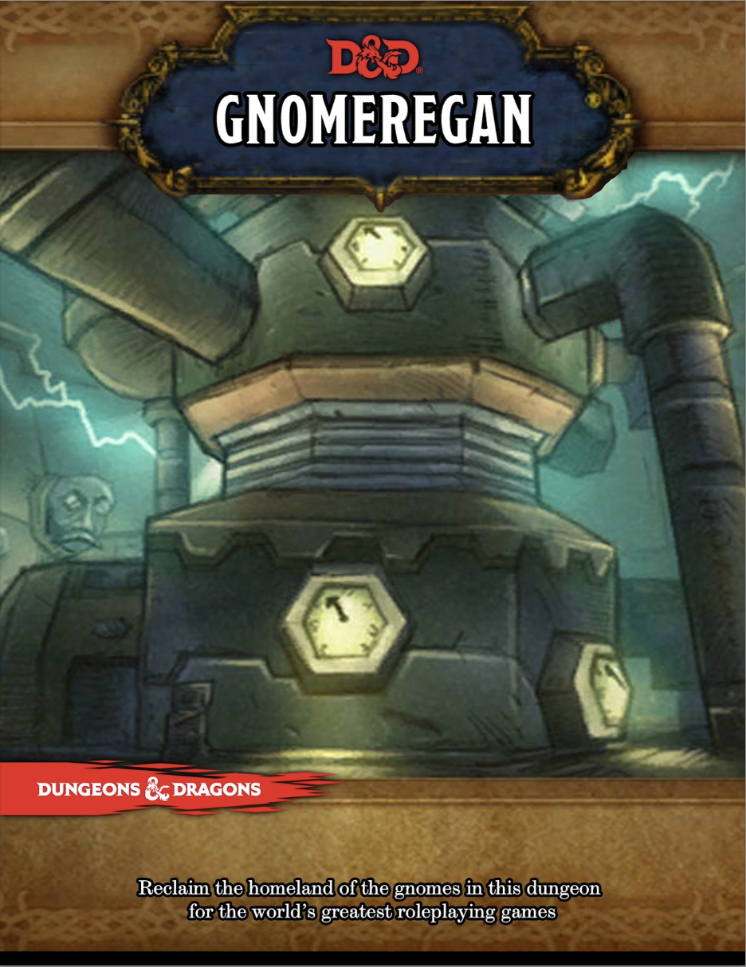

Gnomageddon

🧠 Operation: Gnomeregan — Player Intro
Gnomeregan was once the glittering subterranean capital of the gnomes: a labyrinth of workshops, launch bays, laboratories, and living quarters humming with innovation. But when troggs invaded from the deep tunnels, High Tinker Mekkatorque ordered the defenses activated. His trusted advisor, Sicco Thermaplugg, betrayed him—flooding the lower levels with toxic radiation in a desperate attempt to halt the invaders.
The radiation didn’t just kill; it mutated and warped everything it touched. Troggs thrived in the chaos, leper gnomes formed fanatical factions, and deep below, ancient vents and forgotten laboratories split open—unleashing oozes, slimes, and other strange things that had been sealed away for centuries.
Now, the surviving gnomes have rallied. Operation: Gnomeregan has begun. Commandos and volunteers are striking back, room by room, to reclaim their city. But the lower you go, the stranger—and deadlier—the ruins become.

📜 OPERATION: GNOMEREGAN
Mission Briefing – Volunteer Strike Teams
Issued from the Forward Encampment, Tinkertown
To all Volunteer Operatives,
This is it. After years in exile, the time has come to take our home back. Gnomeregan, once the jewel of gnomish innovation, lies beneath us—its halls choked by betrayal, radiation, and monsters. Sicco Thermaplugg’s treachery and the trogg invasion turned our shining city into a nightmare, but no longer.
Your mission is simple but dangerous:
- Penetrate the upper tunnels through the secured breach points.
- Push deeper into the city, securing control of key junctions and disabling enemy defenses.
- Neutralize hostile forces, including trogg warbands, leper gnome loyalists, and Thermaplugg’s malfunctioning mechanized guardians.
- Report and recover advanced technologies where possible. Many labs were sealed in the chaos; anything you find could be vital.
Be warned:
Delving too deep doesn’t only risk trogg hordes. In the lowest levels, radiation ruptured containment vaults and unleashed strange oozes, slimes, and experimental entities long forgotten. The deeper you go, the stranger—and more unstable—things become. Many who descended too far were never seen again.
Our engineers have established surface relay stations, but beyond a certain depth, you will be on your own. Expect power surges, shifting passages, and Thermaplugg’s deranged broadcasts.
Failure is not an option. Every corridor you reclaim brings us closer to home.
For Gnomeregan.
For the Alliance.
— High Tinker Gelbin Mekkatorque
Forward Operations Command

☣️Gloomium (Radiation)

Background Radiation
Certain parts of the dungeon are drenched in radiation. PCs in this area must make a DC 21 Fortitude save or gain Gloomium Sickness (see below).
Area | Evidence / Description | Suggested Rule / Severity
Lower Level of  Hall of Gears | The module explicitly states: “The bottom of the Hall of Gears is an uninhabitable mess of debris and radiation. Toxic fluids drip … clouds of poisonous mist … When a creature enters this room, they must succeed on a DC 14 Constitution saving throw … make this saving throw every minute they are in the Lower Level.” (GM Binder) | Use this as your baseline: persistent radiation (see below) applies in this zone.
Irradiated Tramway (part of the Launch Bay connection) | The “Hazard Table” for the Irradiated Tramway includes a “Radiation!” entry: “must succeed DC 15 Con or take poison damage and be Poisoned.” (GM Binder) | This zone should probably have a lighter level of persistent radiation, in addition to the hazard.
Test Chamber / Engineering Labs deep zones | Because these are the heart of machines, coils, power lines and experimental devices, the lore implies they have extreme energy leakage. (Though the module doesn’t explicitly state an ongoing poison field there, it’s implied by the flux and “humming pipes.”) (GM Binder) | These are good candidates for moderate persistent radiation.
Tinkers’ Court / Tinkers’ Chambers | Thermaplugg’s throne room is described as having bomb assemblies, coils, and electromagnetic devices overhead, likely leaking energy and radiation. (GM Binder) | This could be the highest tier of persistent radiation — or have periodic surges.

When in Tinker’s Court the radiation is so intense that the Gloomium Sickness changes to rounds instead of hours/days.

Gloomium damage type
Gloomium is radiation damage and can trigger mutations. Gloomium damage is both fire and poison damage. The initial check is for poison, if a creature is immune to poison (or takes no damage from poison) then the damage type is changed to fire. Only a creature wholly immune to fire and poison takes no damage.
When a creature takes gloomium damage if it has immunities this is reduced to resistance equal to ½ his/her level. Each time s/he takes damage after this point, resistance is reduced by 5 points until it becomes weakness5. This weakness can be cured by magic or the Treat Wounds skill. The DC for treat wounds to be effective is equal to the creature’s level that inflicted the weakness.
For spell casting any curative spell works, but a counteract check must also be made (DC equal to the creature that inflicted the weakness).

Gloomium Sickness and Mutations
Gloomium Sickness
(poison, disease, radiation, virulent)
Exposure to unstable arcane fallout or the breath of a nuclear toxyderm inflicts this mutagenic sickness. Victims don’t just wither — they warp.
Saving Throw Fortitude (DC = the level-based standard DC for the effect’s source; usually level 16 for a nuclear toxyderm = DC 34).
Onset 1d4 hours
Stage 1 sickened 1 (1 day)
Stage 2 sickened 2 and fatigued (1 day)
Stage 3 sickened 3 and enfeebled 2 (1 day)
Stage 4 mutation (see below); permanently sickened 1 until cured (note the sickened can be cured separately from the mutation using spells or Treat Wounds).
The victim must attempt a new save at the end of each stage. A critical failure moves them two stages at once.

Mutation Trigger
If a creature reaches sickened 3 from gloomium (whether via the affliction’s stage progression or a critical failure effect such as a nuclear toxyderm’s breath):
- It must attempt a Fortitude save against the standard DC for its own level (e.g., DC 32 at level 13).
- Failure: The creature gains a mutation. The GM may select or roll on a mutation table — beneficial, horrific, or both. Mutations are permanent until removed.
- Critical Failure: The mutation manifests violently — the creature also takes 6d6 gloomium damage and is stupefied 1 for 24 hours.

Curing Gloomium
- Gloomium is virulent; the stage duration increases by 1 day for every failed save.
- Spells that can remove it include remove affliction, restoration (7th-level), or cleanse affliction (if you use remaster versions).
- The caster must succeed at a counteract check against the affliction DC.
- Mutations are not automatically removed when gloomium is cured. Removing a mutation requires a separate remove curse, regenerate, or miracle/wish-tier effect, with a successful counteract check against the original mutation DC.

Encrusted Item
If the party uses the sparklematic on an encrusted item roll for a random cyper or oddity (50/50 for either).

Random Encounters
Random encounters should be rolled only if a second short rest is taken by the PCs. Its 1 in 6 chance escalating.

Rewards
Tell the PCs this is a bit of a boss rush type dungeon. Rewards for successfully defeating all the bosses:
- Gain a level.
- Made citizens of Gnomageddon. All svirfneblin (deep gnomes) will have a friendly attitude towards them.
- City is fully functional within a week (the city is level 15 and considered a safe haven).
- They are gifted Magic Missile grenades.
- They are gifted “The Ogre” a gun.

Gnome Hero
It holds that the Derro Powers are the sworn enemies of Callarduran Smoothhands and have ever tried to destroy him and his realm, by the most evil and deceitful means imaginable. Many, many legends are told about this, and gnome stories go on for ages, so the PC is in for some down time here. The gnome PC should be fed well (and not just on fungus), wined, and made to feel like his or her deep cousins have really accepted him or her.
The DM should then pick a time, later in the campaign, when the PCs have just won a hard-fought victory. Thiscan't be scripted; it depends on the drama and closeness of the situation. Judge it by when your players almost collapse with relief after a famous victory, but it should be before they have met any Derro. If they meet the Svirfneblin again, and relate their heroic deeds, now comes the killer punch. The priestess wants to see the gnome PC alone. After fine food and wine, Carmeneren gives the PC a drink of Gogondy, the special wine of the deep gnomes they give only to their most trusted friends (see the Svirfheblin section in PHBR9, The Complete Book of Gnomes & Halflings, for more on "the finest wine in the world"). Accepting this drink essentially make the PC a member of the Svirfneblin community. The old priestess then produces, with due pomp and circumstance, a truly fine magical item. This should be a +3 magical melee weapon appropriate to the PC's class, and it also has the properties of a ring of protection +1 (likely a rocket gnomish hammer, see below). In addition, Derro attack rolls are at a -2 penalty against the weapon user.
She lets the character examine the item but not take it yet. In return for this fine gift, reserved for the Svirfneblin's champion through the generations, Carmeneren wants the gnome PC to voluntarily accept a quest spell from her.
Carmeneren asks the player-character gnome to attack Derro whenever possible and never to offer them succor or alliance. This is not a kamikaze, "kill them on sight" proposition. However, once in combat the quest prevents the gnome PC from fleeing combat unless his or her hit points are reduced to below one-half his or her normal maximum.
It means absolutely that any form of alliance with Derro is utterly repellent to the gnome PC (a significant liability later in the campaign). But the magical weapon is so beautiful and so powerful... Carmeneren asks the gnome to decide whether to accept the weapon, and the quest, on his or her own. She does not want other PCs involved.
If the PC doesn't want to accept the quest and offers a good reason (he or she doesn't want to constrain the actions of other PCs, his or her friends and trusted fellow adventurers, etc.) Carmeneren looks disappointed butdoes not hold this against the PC. However, she withholds the weapon in this case, as it is the appointed tool of their champion. A PC who accepts the quest becomes this generation's champion for the Svirfneblin community (+4 bonus to all reaction rolls involving deep gnomes).

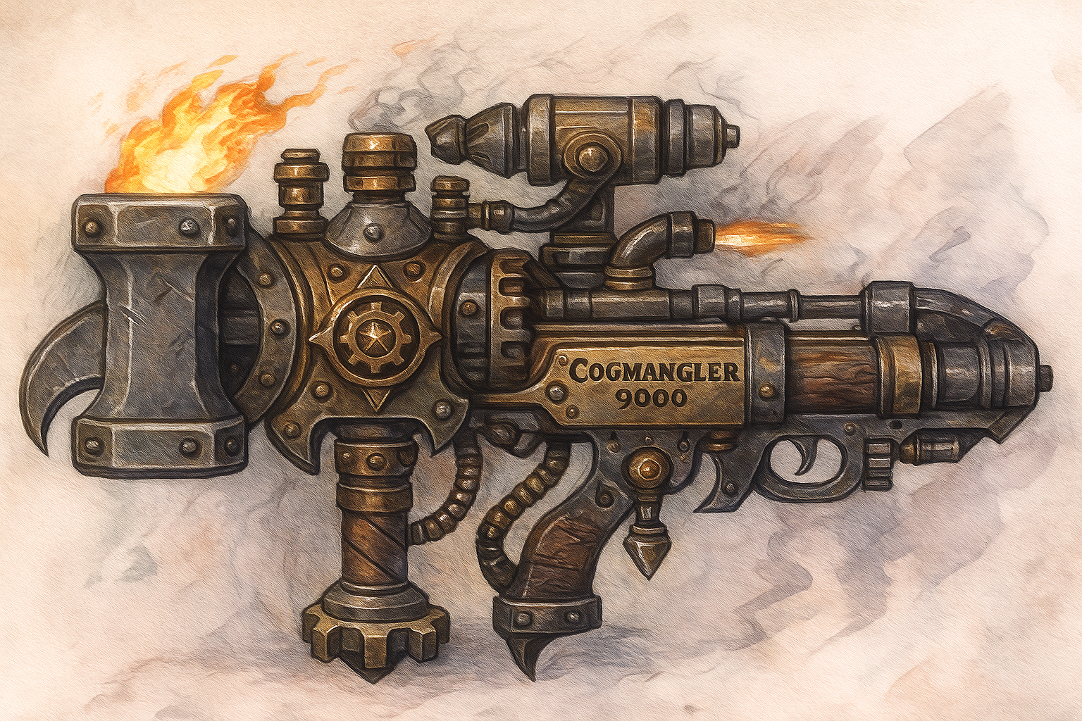Cogmangler 9000
Unique, Artifact-like Gnomish Hybrid Weapon
Item 14; Price 4,000 gp; Bulk 2; Traits Gnome, Combination, Magical, Tinker, Rare
This bizarre but masterfully engineered device combines a gnomish hooked hammer and a gnome-amalgam musket, covered in rivets, pipes, and tiny runic plates. The weapon constantly ticks, hisses, and emits faint blue sparks. A collapsible spring-propelled rocket chamber is built into the haft, used only once per day for devastating effect.

Usage
- Melee (hooked hammer head):
- +2 striking gnomish hooked hammer.
  - Hammer end: Damage 2d8 bludgeoning, shove.
  - Hook end: Damage 2d6 slashing, trip.
- Ranged (musket barrel):
- +2 striking amalgam musket.
  - Damage 2d8 piercing, range increment 40 ft., reload 1.

Activate — Rocket Propelled Strike [◆◆] (Evocation, Fire, Force, Magical)
Frequency once per day.
Effect You load the rocket chamber and fire a devastating hybrid strike. Choose melee or ranged:
- Melee: You leap forward up to 20 feet in a straight line and make a melee Strike with the hammer or hook. On hit, add 3d12 fire damage and push the target 10 feet. On a critical hit, the target is knocked prone.
- Ranged: Fire the rocket shell in a 30-foot line. Each creature in the line must attempt a DC 32 Reflex save.
  - Critical Success: No damage.
  - Success: Half damage.
  - Failure: 45 (9d10) fire + force damage.
  - Critical Failure: As failure, plus knocked prone.
After use, the rocket chamber ejects molten fragments and cannot be reloaded until the next day.

Traits
Counts as both a gnomish hooked hammer and musket for proficiency and effects.
When wielded by a gnome, the wielder gains a +1 circumstance bonus to Athletics checks to Trip or Shove and to Crafting checks involving firearms.

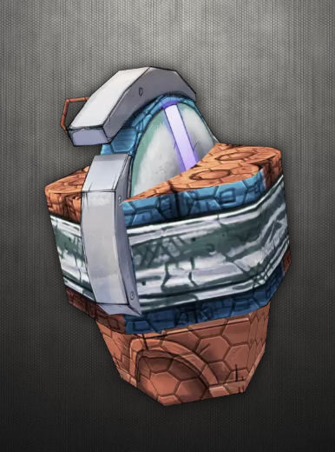
“Magic Missile” Grenade — Item 14
Consumable • Bomb • Force • Magical • Thrown 20 ft.
Price 4,000 gp • Bulk L • Usage held in 1 hand, Activate [◆] Interact (to throw)
Effect You hurl the compact arcane charge; at detonation, it blossoms into seeking darts of force that strike visible foes with uncanny accuracy.
- On Detonation: Create 8 force darts that automatically hit creatures you can see within 120 feet (you choose how to divide the darts; a single creature can be targeted by up to 4 of the darts).
  - Each dart deals 7 (2d4+2) force damage. (No attack roll, no save.)
  - Total if all 8 fire: 56 force (split across targets as chosen).
- Homing Logic: If there aren’t enough visible enemies, any unassigned darts delay and then launch at the start of your next turn at the nearest enemy you can see (still within 120 feet). If none qualify then, the remaining darts dissipate.
- Precision Targeting: Darts ignore concealed and cover, but not hidden/undetected creatures.
- Shield Interaction: shield (or other effects that specifically block magic missile) can block darts as normal; each blocked dart reduces damage by its full amount.
Craft Requirements Crafting (Arcana) + master; the formula, magic missile in your repertoire or from an attached spellheart.
Depletion Rules: The grenades regenerates automatically but slowly. The weapon depletes on a 1 in 6, -1 for each previous use (ie it automatically fails on the 6th use). It cant be used again until a Long Rest has happened (daily preparations) as the grenade slowly rebuilds itself.

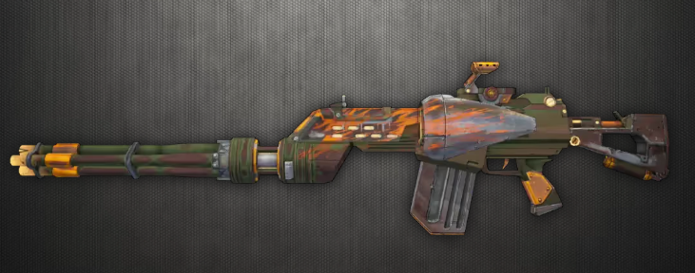
THE Ogre
Unique • Weapon • Martial • Firearm • Explosive • Volatile
Level 14 • Price 4,200 gp • Bulk 2 • Usage held in 2 hands
A lumbering, jury-rigged hand-cannon that lobs unstable explosive shells in wild arcs. It is feared not for its accuracy but for its sheer destructive chaos.

Base Weapon
- Type: +2 potency, greater striking firearm (already included)
- Range: 60 feet
- Reload: 1
- Damage: 2d10 piercing plus 2d6 fire in a 10-foot burst centered on impact (basic Reflex save DC 32 for creatures in the burst).
- Traits: firearm, explode 10 (fire), fatal d12, inaccurate, volatile, sustained barrage

Inaccuracy
Whenever you make a Strike with the Ogre:
- On a hit, resolve normally.
- On a miss, roll a d8 scatter die; the shell instead explodes in a random square within 1d4 × 10 feet of the intended target.
- On a natural 1, the Ogre automatically misfires (see below).

Volatile Misfire
- On a natural 1, instead of the normal scatter, the Ogre detonates dangerously:
  - The wielder and all creatures in a 10-foot burst centered on the wielder must attempt a DC 32 Reflex save.
    - Failure: 21 (6d6) fire damage.
    - Success: Half damage.
- After this, the Ogre is depleted (see below).

Depletion
The Ogre is a dangerously unstable weapon.
- Automatic Depletion: On a natural 1, the Ogre immediately becomes depleted.
- Depletion Roll: Each time you fire the Ogre (other than a natural 1), roll a flat check DC 6. On a failure, the weapon is depleted.
- A depleted Ogre becomes unusable until repaired (Crafting DC 34, 8 hours, 500 gp in exotic parts).

Ogre Barrage [◆◆]
You wildly unleash a storm of shells. Make two Strikes with the Ogre, applying MAP only once. Both attacks follow the Inaccuracy rules above.

Sustained Barrage
If you spend all of your actions in a turn firing the Ogre (no movement, reactions, or non-Ogre actions) the weapon enters a runaway firing mode:
- The Ogre automatically ignores its reload requirement until the end of your turn.
- Each additional Strike after the first increases the fire portion of the damage by +2d6 fire (cumulative).
- MAP still applies normally.
- At the end of your turn, roll a flat check DC 6; on a failure, the Ogre immediately becomes depleted.

🤖Bestiary

Leper Gnome Forces
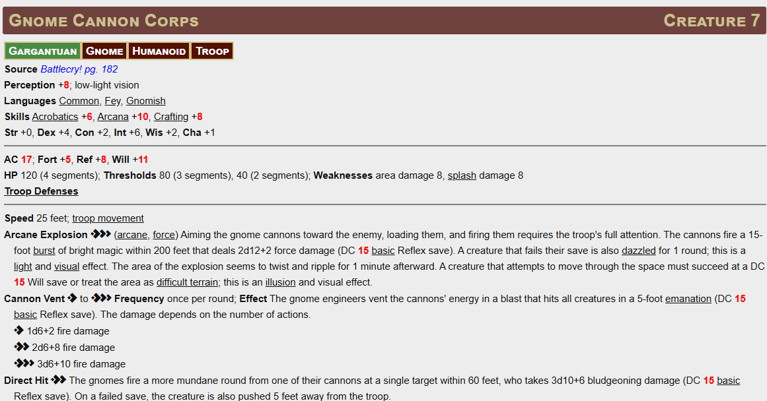
Use this generic force when Leper gnomes are encountered.

Leper Mechanized Forces
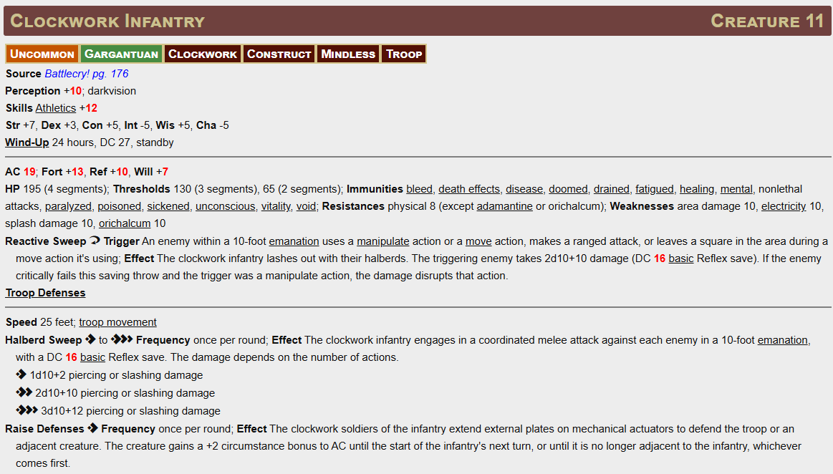
Use this generic force when Leper gnomes are encountered.

Leper Gnome Enginseer Lazella and her Clockwork Wolfhound

Enginseer Lazella
Razzle Dazzler Creature 5
Small Gnome Humanoid
Perception +7; low-light vision
Languages Common, Elven, Fey, Gnomish
Skills Arcana +5, Deception +9, Diplomacy +9, Intimidation +7, Performance +9, Thievery +7
Str +1, Dex +3, Con +1, Int +2, Wis +1, Cha +4
Items dagger, dueling cape, hand crossbow (20 bolts), windup wolfhound blueprint

AC 15; Fort +4, Ref +7, Will +10
HP 78
Daunting Charisma [free-action] Trigger The razzle dazzler rolls initiative using Deception or Performance; Effect The razzle dazzler can attempt to Demoralize one creature they can see.

Speed 25 feet
Melee [◆] dagger +8 [+4/+0] (agile, finesse, versatile S), Damage 1d4+3 piercing
Melee [◆] fist +8 [+4/+0] (agile, finesse, nonlethal, unarmed), Damage 1d4+3 bludgeoning
Ranged [◆] hand crossbow +8 [+3/-2] (range increment 60 feet, reload 1), Damage 1d6+2 piercing
Ranged [◆] dagger +8 [+4/+0] (agile, finesse, thrown 10 feet), Damage 1d4+3 piercing
Dazzling Duplicate [◆] (arcane, concentrate, illusion, manipulate) The razzle dazzler creates an illusory duplicate of themself in their space that lasts for 1 round. A creature who attacks the razzle dazzler must first attempt a DC 11 flat check. On a failure, the attack misses the razzle dazzler and destroys the illusion instead, ending this effect.

Arcane Spontaneous Spells DC 17, attack +10

3rd (3 slots)
• Enthrall (30 ft burst; Will; Fail = fasc 1 min; Incap)
• Hypnotize (30 ft; Will; Fail = fasc 1 min; Incap)
• Illusory Disguise (1 hr; visual disguise; 1 target)

2nd (4 slots)
• Illusory Creature (30 ft; figment; AC 19; 3d8 [13] on hit; Sust)
• Illusory Object (30 ft; 10-ft cube illusion; Sust)
• Laughing Fit (30 ft; Will; Fail = Stunned 1 rd; Crit Fail = Stunned 1 min; Incap)
• Revealing Light (120 ft; 4d6+2 [16] good; counteract invis)

1st (4 slots)
• Dizzying Colors (15-ft cone; Will; Fail = Dazzled 1 rd; Crit Fail = Stunned 1 rd)
• Illusory Disguise (as above, 1 hr)
• Illusory Object (as above)
• Ventriloquism (30 ft; voice projection; Sust)

Cantrips (3rd)
• Telekinetic Projectile (30 ft; +10 atk; 2d6+2 [9] B/P/S)
• Figment, Light, Prestidigitation, Telekinetic Hand (non-combat skipped)

GUUR, Clockwork Wolfhound
Modified Clockwork Soldier Creature 6
Uncommon N Medium Clockwork Construct Mindless
Perception +10; darkvision
Skills Athletics +9 (+11 to Disarm, Grapple, or avoid being Disarmed)
Str +6, Dex +2, Con +4, Int -5, Wis +4, Cha -5
Wind-Up 24 hours, DC 22, standby
Items +1 bite

AC 18; Fort +10, Ref +8, Will +6
HP 80; Immunities death effects, disease, doomed, drained, fatigued, healing, mental, necromancy, nonlethal attacks, paralyzed, poisoned, sickened, unconscious; Resistances physical 5 (except adamantine or orichalcum); Weaknesses electricity 5, orichalcum 5
Attack of Opportunity [⟳]; the wolfhound has two reactions, one can only be used for AoO.
Raise Shield [⟳] see DEFENSiGIZMO Subroutine

Speed 35 feet
Melee [◆] bite +12 [+7/+2] (magical, reach 10 feet, versatile S), Damage 1d10+9 piercing plus Knockdown (free action, +12 vs Athletics DC)
Ranged [◆] heat ray +10 [+6/+2] (agile, fire), Damage 1d8+9 fire
DEFENSiGIZMO Subroutine [◆ or ⟳] The wolfhound projects a shield of force to defend the hound or an adjacent creature of the wolfhound's choice (usually the bearer of the brass key). The creature gains a +2 circumstance bonus to AC until the start of the wolfhound's next turn, or until it is no longer adjacent to the wolfhound, whichever comes first. The wolfhound's can have no more than one shield active at a time.
DEFENSiGIZMO Subroutine also grants the Shield Block reaction as a free action while active. It has Hardness of 10 but, once it absorbs damage, it dissipates until reactivated.
Finally, while active, the protected ally has a base AC equal to the wolfhound’s AC if higher.

🧪 Leper Gnomes (Trash Mobs / Swarms)
(Tone: deranged, self-aware, occasionally pitiable)
- “Don’t breathe too deep… it’s catchy!”
- “I used to be normal! Hah… what a joke.”
- “We’re the cutting edge of hygiene!”
- “My spleen’s not supposed to glow, is it?”
- “Somebody call a medic—no wait, don’t!” (death)
- “’ll never get to ride a spider!” (death)

🧠 Optional Ambient / Minion Support Lines
If you have extra robotic or leper assistants during boss fights, sprinkle in a few of these between rounds:
- “Initiating panic subroutine!”
- “Is this supposed to hurt them or us?!”
- “This is why we don’t have health insurance anymore!”
- “No refunds!”

Tin Templar
Mechanical paladin forged of metal, crystal, and logic.

Iron Warden Creature 13
Uncommon Large Construct Mindless
Perception +8; darkvision
Skills Athletics +17
Str +8, Dex -1, Con +4, Int -5, Wis +0, Cha -5
Items harvested from the remains by anyone proficient in crafting – Soulstone
Shield Arm The iron warden has a shield built into its arm, that it can use as a steel shield (+2 to AC and Hardness 5). Because it's a part of the iron warden, all damage in excess of its Hardness is dealt only to the iron warden.

AC 20; Fort +13, Ref +6, Will +9
HP 190; Immunities bleed, death effects, electricity (heals templar), disease, doomed, drained, fatigued, healing, mental, nonlethal attacks, paralyzed, poison, sickened, spirit, unconscious, vitality, void;
Resistances physical 15 (except adamantine), spells 15 (except acid and spells that cause rust)
Shield Block [reaction] (see shield arm). If the damage is electrical, the attacks is bounced back to its source.

Speed 20 feet
Melee [◆] sword +15 [+10/+5] (magical, reach 10 feet), Damage 27 (3d10+12) bludgeoning or electricity.
Inexorable March [◆] The iron warden Strides up to its Speed, pushing back each creature whose space it moves into and damaging them if they try to stop its movement. A creature can attempt to bar the way by succeeding at a DC 24 Fortitude save. On a critical success, the resisting creature takes no damage; otherwise, it's damaged as if hit by the iron warden's sword.
Breathe Poison [◆◆] (arcane, poison) The iron warden exhales poisonous gas in a 10-foot burst centered on the corner of one of the iron warden's squares. The gas persists until the start of the warden's next turn. Any creature in the area (or that later enters the area) is exposed to the iron warden's poison. The warden can't Breathe Poison again for 1d4 rounds.
Iron Warden Poison (poison) Any drained value from this poison is reduced by 1 every hour; Saving Throw DC 20 Fortitude; Maximum Duration 4 rounds; Stage 1 2d6 poison and drained 1 (1 round); Stage 2 4d6 poison and drained 2 (1 round); Stage 3 8d6 poison and drained 3 (1 round)

Bronze Butcher
Level 13 Elite Construct Boss
Creature 13 (Elite) | LE Large Construct
Perception +26; darkvision
Languages Gnomish (understands)
Skills Athletics +29, Acrobatics +25
Str +6, Dex +4, Con +6, Int +2, Wis +4, Cha +1
AC 38; Fort +30, Ref +27, Will +24
HP 285; Hardness 10 vs nonmagical
Immunities bleed, fire, disease, mental, paralyzed, poison, unconscious
Resistances physical 10 (except adamantine)
Weaknesses rust 15 (acid damage qualifies)
Items (Harvest) 1d6 fine bronze scimitars (masterwork), 50 ft. bronze wire (climbing gear equivalent), Bronze shield (+2 bonus; Hardness 10, HP 50, BT 25)

Melee [◆] — Bronze Scimitar +14 to hit; Damage 3d12+12 slashing.
Melee [◆◆] — Arcing Smash The Butcher makes a single Strike against up to three adjacent targets. Roll once; compare against each AC. Damage as above.
Shapechange [◆] (arcane, transmutation) The Butcher shifts between three forms. Can revert as a free action [◇]:
- Soldier: Four arms, dual scimitars, four actions.
- Giant Spider: Gains climb speed 40 ft., can use Web Strike (DC 17 Reflex or cocconed (Immobilized)).
- Rhino: Gains Trample (DC 21 Reflex; 6d10 bludgeoning, prone on fail).
Rust Averse [⟳] If struck by acid damage, the Butcher emits a screech and gains Frightened 1 for 1 round.

Wants order. Fears rust.
- “None may pass.”
- “This is unacceptable.”
- “Flesh is inferior.”
- “Pathetic monoforms!”

Grubbis
Xulgath Deepmouth Creature 12
Uncommon CE Medium Humanoid Xulgath
Perception +14; darkvision
Languages Draconic, Undercommon
Skills Acrobatics +10, Crafting +10, Diplomacy +13, Intimidation +13, Medicine +13, Religion +13, Society +10
Str +2, Dex +4, Con +2, Int +4, Wis +7, Cha +5
Items bone religious symbol of Zevgavizeb, +1 hide armor, +1 striking spiked gauntlet, material component pouch

AC 21; Fort +6, Ref +10, Will +13
HP 215
Gloomium Stench (aura, olfactory) 30 feet. A creature that enters the area must attempt a DC 16 Fortitude save. On a failure, the creature is sickened 1, and on a critical failure, the creature also takes a –5-foot status penalty to its Speeds for 1 round. While within the aura, the creature takes a –2 circumstance penalty to saves to recover from the sickened condition. A creature that succeeds at its save is temporarily immune to all xulgaths' stenches for 1 minute.

Speed 25 feet
Melee [◆] spiked gauntlet +9 [+5/+1] (agile, free-hand, magical), Damage 2d4+6 piercingMelee [◆] jaws +8 [+3/-2], Damage 2d6+6 piercingMelee [◆] claw +8 [+4/+0] (agile), Damage 2d4+6 slashingDivine Prepared Spells DC 21, attack +15; 6th divine wrath, enervation, harm (×6), repulsion (×2); 5th heal (×2), ravening maw; 4th air walk (×2); 3rd heroism, meld into stone, vampiric touch; 2nd status (×3); 1st protection, ray of enfeeblement (×2); Cantrips (6th) chill touch, daze, detect magic, shield
Cleric Domain Spells DC 21, 3 Focus Points; 6th commanding lash, vibrant thorns
Divine Rituals; 6th commune; 2nd consecrate
Devourer's Dictum [◆] (concentrate) The deepmouth warps part of a scalescribed creature's flesh into a mouthed tentacle, then wills it to lash out. The deepmouth makes a jaws Strike that originates from any living scalescribed creature within 120 feet; this Strike also has reach 15 feet and deals an additional 2d8 negative damage. If the Strike originates from a creature other than the deepmouth, that creature triggers reactions as though it had made the Strike.Scalescribe (manipulate) With 10 minutes of work, a deepmouth can carve a magical rune called a scalescript on the flesh of a living, willing xulgath (including the deepmouth itself). A creature cannot be inscribed with more than one scalescribe rune at a time, and a deepmouth can create and maintain no more than three scalescripts at a time. If the deepmouth Scalescribed itself, it can provide material and somatic components while Casting a Spell without a free hand.

Chomper
Basilisk Creature 5
Medium Beast
Perception +6; darkvision
Skills Athletics +8, Stealth +3
Str +4, Dex -1, Con +5, Int -3, Wis +2, Cha +1

AC 17; Fort +9, Ref +3, Will +6
HP 75; Immunities petrified
Petrifying Glance [⟳] (arcane, aura, visual) Trigger A creature within 30 feet that the basilisk can see starts its turn; Effect The target must attempt a DC 15 Fortitude save. If it fails, it's slowed 1 for 1 minute as its body slowly stiffens.

Speed 20 feet
Melee [◆] jaws +10 [+5/+0], Damage 2d8+4 piercingPetrifying Gaze [◆◆] (arcane, concentrate, incapacitation, visual) The basilisk stares at a creature it can see within 30 feet. That creature must attempt a DC 17 Fortitude save. If it fails and has not already been slowed by Petrifying Glance or this ability, it becomes slowed 1. If the creature was already slowed by this ability or Petrifying Glance, a failed save causes the creature to be petrified permanently.
A creature petrified in this manner that is coated (not just splashed) with fresh basilisk blood no more than 1 hour old is instantly restored to flesh. A single basilisk contains enough blood to coat 1d4 Medium creatures in this manner.

Irradiated Trog Troop
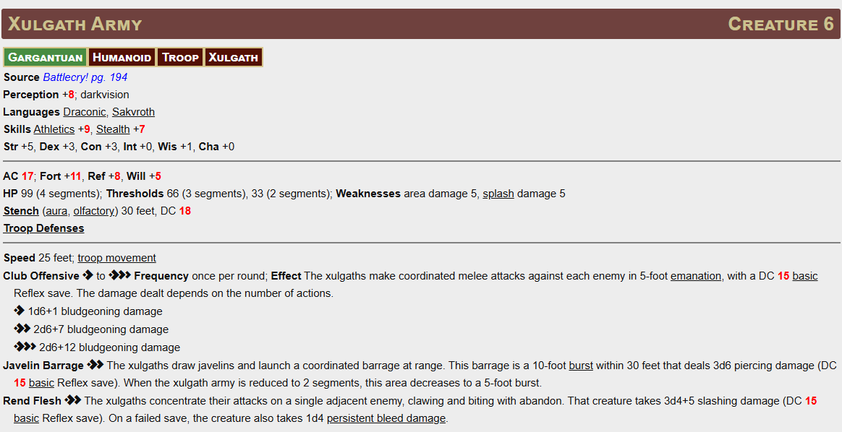
Use this for any Trog encounter. They also give off radiation as part of their stench, so a fail save causes sickness 1 while in their prescence.

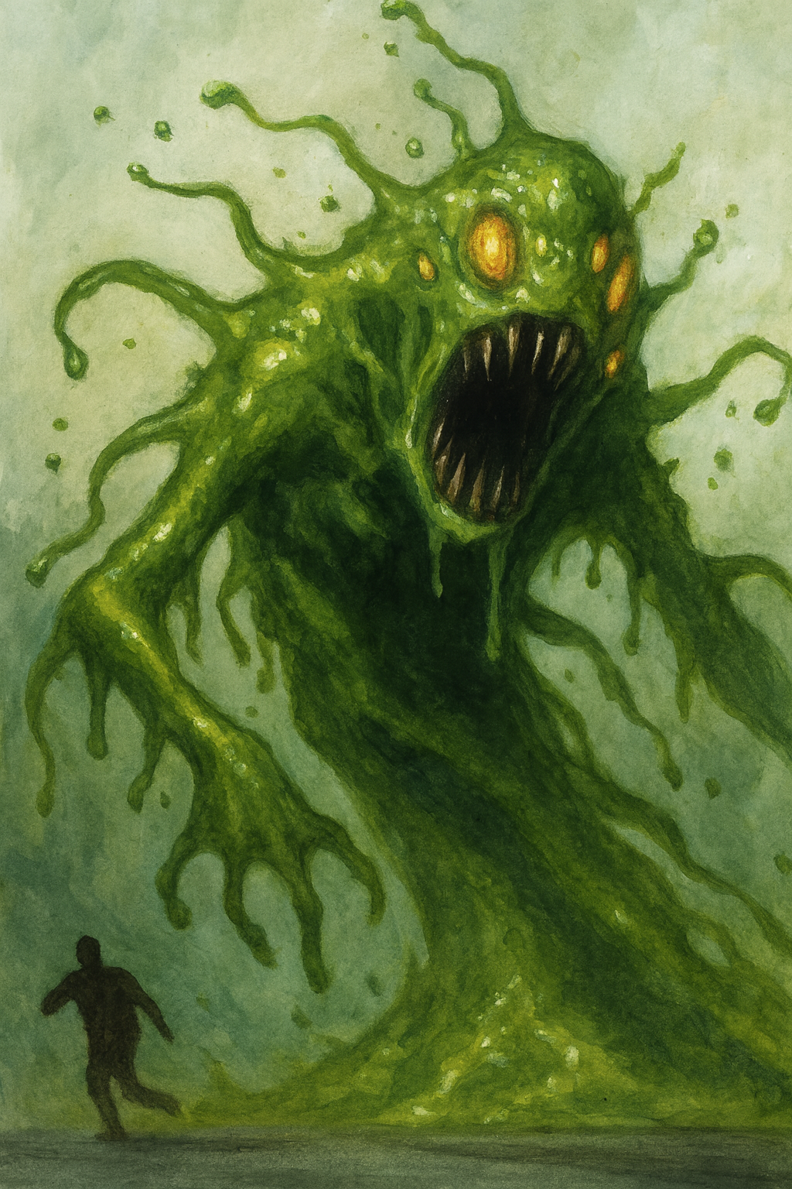
Vicious Fallout
Gloomium Elemental CR 16
NE Uncommon Huge Elemental (gloomium)
Perception +9; darkvision 120 ft.
Languages Auran, Common
Skills Athletics +13, Intimidation +10, Stealth +9
Str +7, Dex +2, Con +6, Int –1, Wis +1, Cha +2
AC 23; Fort +14, Ref +9, Will +8
HP 340; regeneration 20 (suppressed by vitality damage)
Immunities gloomium; bleed, paralyzed, poison, sleep
Resistances fire 15, void 10
Weaknesses vitality 15

Fallout (aura, radiation, void, poison) 40 feet. A creature entering or starting its turn in the aura must attempt a DC 17 Fortitude save.
- Success Sickened 1.
- Failure Sickened 2 and Slowed 1 until the end of its turn.
- Critical Failure As failure, plus 20 (4d6+6) gloomium damage.
Chain Reaction When reduced to 0 HP, the elemental explodes in a 40-foot burst, DC 17 basic Reflex save. Damage 63 (14d6) gloomium. The area remains hazardous terrain for 1 minute, dealing 14 (4d6) gloomium damage each round.
Radioactive Fire. Every time the elemental scores a critical hit, it automatically shoots 1d4 Gloomium Ray as a free action at random targets within range.

Speed 40 feet, climb 20 feet, swim 40 feet
Melee [◆] irradiated slam +16/+11/+6 (magical, reach 15 ft.), Damage 35 (3d12+16) bludgeoning plus 14 (4d6) gloomium and Push 10 feet. On a critical hit triggers Radioactive Fire.
Range [◆] gloomium ray +16/+11/+6 (magical, range 150 ft.), Damage 35 (3d12+16) gloomium.
Engulf [◆◆] DC 17 Reflex, Escape DC 17, Rupture 30. On a failure, a creature is engulfed, taking 35 (3d12+16) bludgeoning plus 14 (4d6) gloomium damage at the start of each of the toxyderm’s turns. A critical failure triggers Radioactive Fire.
Nuclear Slag [◆◆] (poison, fire, primal) The nuclear toxyderm exhales a torrent of molten radioactive gas in a 60-foot cone. Each creature in the area must attempt a DC 18 Fortitude save.
- Critical Success The creature takes no damage.
- Success The creature takes half damage and no further effect and is Sickened 1.
- Failure The creature takes 63 (18d6) poison damage (or fire if immune to poison) and becomes sickened 2.
- Critical Failure The creature takes 126 (36d6) poison damage (or fire if immune), becomes sickened 3, and is exposed to lingering radiation (treat as a level 16 hazard: 6d6 poison damage per round until the sickened condition is removed. Reduce the damage by 1d6 per round).
The nuclear toxyderm can’t use Nuclear Slag again for 1d4 rounds.

Legendary Actions
The toxyderm can take 3 legendary actions per round, one at the end of another creature’s turn.
- Toxic Slam: The toxyderm makes one Irradiated Slam attack.
- Toxic Blast: The toxyderm makes one Gloomium Ray attack.
- Fallout Surge: The toxyderm uses Irradiated Burst.
  - Irradiated Burst [1/turn] (arcane, void, poison) The elemental surges in a 30-foot emanation. Each creature must attempt a DC 17 Fortitude save or take 42 (12d6) gloomium damage and be sickened 1 (sickened 2 on a critical failure). A critical failure triggers Radioactive Fire.

Lair Actions
On initiative count 20 (losing ties), roll randomly for one of these effects:
- Radiation Vent: A geyser of toxic steam bursts in a 20-foot radius within 60 ft. DC 17 Fortitude, 28 (8d6) void and sickened 1.
- Flickering Lights: Radiation pulses; all creatures are concealed until the end of the toxyderm’s next turn.
- Meltdown Pulse (1d4 rounds): A reactor surge deals 21 (6d6) void damage to all creatures and forces a DC 17 Reflex save or be pushed 10 ft.

In addition, a random irradiated ooze spawns from the following list:
- Tallow
- Black Pudding
- Chromatic
- Pyronite
- Gunpowder
- Reroll twice ignoring 6.

Electrocutioner 6000
LN Uncommon Huge Construct (robot, golem, technological) CR16
Perception +9; darkvision
Languages Gnomish
Skills Athletics +10, Intimidation +6, Crafting +9, Survival +5
Str +9, Dex +4, Con +6, Int +0, Wis +0, Cha –2

AC 21; Fort +17, Ref +13, Will +13
HP 350; reanimation protocol (regeneration) 20 (suppressed by electricity damage)
Immunities bleed, death effects, disease, doomed, drained, fatigued, healing, magic (see Golem Antimagic below), mental, necromancy, nonlethal attacks, paralyzed, poison, sickened, unconscious;
Golem Antimagic harmed by electricity (10d8, 2d6 from areas or persistent damage); healed by fire (area 2d10 HP); slowed by cold
Vulnerable To dispel magic, antimagic field (stunned 1d4 rounds).

Speed 30 feet
Melee [◆] shock blade +17/+12/+7 (magical, reach 10 feet), Damage 40 (4d10+18) bludgeoning plus 26 (4d12) electricity
Melee [◆] power kick +17/+12/+7 (magical, reach 15 feet), Damage 36 (4d8+18) bludgeoning plus Push 10 feet
Ranged [◆◆] chain bolt +17/+12/+7 (electricity, range 120 feet), Damage 49 (6d10+18) electricity plus dazzled 1 round. This attack automatically hits up to two additional targets using the current target as the spell's origin point. This can't hit the same target more than once per turn, there is no save, but the damage is halved (25 electrical)

Electrostatic Pulse [◆◆] (arcane, electricity, evocation); Frequency once every 1d4 rounds Effect The Electrocutioner releases a pulse in a 40-foot emanation. Each creature must attempt a DC 21 basic Reflex save. Failure 52 (8d12) electricity damage.
Megavolt [◆◆] (arcane, electricity, evocation); Frequency once per encounter; Effect The Electrocutioner fires a massive surge of lightning in a 60-cone. Each creature must attempt a DC 21 basic Reflex save; Failure 78 (12d12) electricity damage.
Judgment Protocol [◆] (stance) The Electrocutioner enters kill-mode for 1 minute. Its melee Strikes deal an extra 13 (2d12) void damage, but it takes 10 fire damage at the start of each of its turns as its core overheats.
Hard to Kill [⟳] (once per day) The first time Electrocutioner 6000 would be reduced to 0 HP, it instead heals 90 HP (¼ its max HP) and remains standing.
Legendary Actions (3 per round, only one per turn)
- Shocking Step The Electrocutioner moves up to half its speed. Each creature it moves adjacent to takes 14 (4d6) electricity damage (DC 21 basic Reflex).
- Smash Makes one shock fist Strike.
- Magnetic Grip (Recharge 5–6) The Electrocutioner emits a magnetic surge. Each creature within 30 feet carrying metal must succeed at a DC 21 Fortitude save or be pulled adjacent and grabbed.

Electrocutioner 6000 Lair Actions (d6)
On initiative count 20 (losing ties), the Electrocutioner can trigger one of the following effects (reroll duplicates if it doesn’t make sense that round):
d6 | Lair Action | Effect
1 | Tesla Coil Overload | Arcs of electricity leap from hidden coils. Each creature of the Electrocutioner’s choice within 20 feet of a wall must attempt a DC 21 Reflex save. Failure: 49 (11d8) electricity damage and Sickened 1. Success: Half damage.
2 | Power Surge | The floor plates hum with energy. Each enemy on the ground must succeed at a DC 21 Reflex save or take 36 (8d8) electricity damage and become Clumsy 1 until the start of their next turn.
3 | Magnetic Pulse | A polarity field drags metal weapons and armor. Each creature wielding metal or wearing medium/heavy metal armor must succeed on a DC 21 Fortitude save or be Pulled 15 feet toward the Electrocutioner and take 22 (5d6) bludgeoning damage from crashing debris.
4 | Leper Gnome Bombing Run | A squad of deranged leper gnomes swoop through on rocket packs, tossing crude explosives. Each enemy in a 20-foot line must attempt a DC 21 Reflex save. Failure: 20 fire damage. Success: Half damage.
5 | Peacekeeper Artillery Barrage | If the Peacekeeper is active, it fires an overhead strike. Choose a 15-foot burst within 60 feet. All creatures in the area must attempt a DC 21 Reflex save. Failure: 20 bludgeoning + fire damage. Success: Half damage.
6 | System Malfunction | The chamber shudders as pressure valves blow. Steam vents open in three 10-foot squares of the GM’s choice. Each creature starting its turn in one of these squares takes 20 (6d6) fire damage (no save). The vents last until the next lair action.

⚡ Electrocutioner 6000
(Tone: dramatic robot hype man, a bit theatrical)
- “Maximum voltage… minimum survival!”
- “Prepare to be upgraded into a smoking crater.”
- “Do not be alarmed. This will hurt.”
- “Error 404: Mercy not found.”
- “You’ll look great as a conductive paste!” (on crit or special attack)
👉 Consider adding a short “boot-up chant” as the fight starts, like:
“Initiating obliteration protocol… three, two, ZZZZT!”

Crowd Pummeler 9-60
Crowd Pummeler 9-60 — Creature 14
LN Uncommon Huge Construct, Robot
Perception +9; darkvision
Languages Common, Necril, Utopian (can’t speak)
Skills Athletics +12, Intimidation +7
Str +7, Dex +2, Con +6, Int +0, Wis +2, Cha –1
AC 22; Fort +13, Ref +7, Will +8
HP 300; regeneration 15 (suppressed by fire or sonic)
Resistances physical 15 (except skymetal)
Immunities bleed, death effects, disease, doomed, drained, fatigued, healing, magic (see Golem Antimagic below), mental, necromancy, nonlethal attacks, paralyzed, poison, sickened, unconscious;
Golem Antimagic harmed by electricity (6d10, 2d8 from areas or persistent damage); healed by force (area 2d10 HP); slowed by cold
Vulnerable To disintegrate (takes double damage, even on success).

Calibration Field (aura, mental, mechanical) 20 feet. The Pummeler emits an oppressive oscillation of gears and pistons. Creatures in the aura take a –1 status penalty to attack rolls for each of their allies adjacent to them (max –3).

Speed 35 feet
Melee [◆] pummeling fist +15/+10/+5 (reach 15 feet, magical), Damage 36 (4d10+18) bludgeoning and the target must succeed at a DC 22 Fortitude save or be stunned 1 (critical failure: stunned 2) and knocked into the air 30 feet.
Melee [◆◆] arcing smash +15/+10/+5 (reach 15 feet, magical, up to 3 targets), Damage 36 (4d10+18) bludgeoning and the target must succeed at a DC 22 Fortitude save or be stunned 1 (critical failure: stunned 2).
Melee [◆] crushing stomp +15/+10/+5 (reach 10 feet, magical), Damage 28 (3d8+18) bludgeoning; each creature adjacent to the target must succeed at a DC 20 Reflex save or take 14 (2d8+7) bludgeoning damage.
Trample [◆◆◆] Large or smaller, crushing stomp, DC 22
Ranged [◆] debris hurler +9 (range 60 feet, magical, thrown), Damage 34 (4d8+18) bludgeoning and the target must succeed at a DC 20 Reflex save or fall prone.
Crowd Pummel [◆◆] (attack, sonic) The Pummeler smashes the ground in a 20-foot emanation. Each creature in the area must attempt a DC 22 Fortitude save.
- Critical Success The creature is unaffected.
- Success The creature is pushed 5 feet and stupefied 1.
- Failure The creature is pushed 10 feet and knocked prone, is stupefied 1 and takes 36 (4d10+18) bludgeoning.
- Critical Failure As failure, plus the creature is stupefied 2 and stunned 1.
Gyro-Knockback [◆◆] (move, attack); The Pummeler extend and spins its massive arms in a 30-foot emanation. Each creature in the area must attempt a DC 22 Reflex save.
- Success Half damage.
- Failure 42 (12d6) bludgeoning damage, stupefied 1 and pushed 15 feet.
- Critical Failure Double damage, stunned 1, stupefied 1 and pushed 30 feet.
Overclocked Pummel [◆◆◆] (attack, incapacitation) The Pummeler makes three pummeling fist Strikes, each against a different target. These attacks do not take the multiple attack penalty.

🤖 Crowd Pummeler 9-60
(Tone: lumbering junkyard brute, cheerful but destructive)
- “HUG. WITH FISTS!”
- “Incoming crowd control… permanently!”
- “You look smashable today!”
- “Warning: May contain traces of violence.”
- “I call this move… the meat tenderizer!” (special attack)
👉 He works best with short, punchy lines you can bark every other round to give him presence without overwhelming the scene.

Reaction
Hard to Kill [⟳] (healing, once per day) Trigger The Pummeler would be reduced to 0 HP. Effect It heals 75 HP and avoids being destroyed.

Legendary Actions
The Pummeler can take 2 legendary actions per round, only one at a time, at the end of another creature’s turn.
- Piston Jab: Make one pummeling fist Strike.
- Hydraulic Reset (1/turn): The Pummeler ends one condition affecting it (slowed, immobilized, prone).
- Recalibrate Field: The Calibration Field’s penalty increases to –2 (max –4) until the start of its next turn.

Optional Lair Actions (if in factory/industrial area)
On initiative count 20 (losing ties), one of the following may trigger:
- Conveyor Surge: The floor shifts; each creature must succeed at a DC 20 Reflex save or be moved 10 feet in a random direction.
- Irradiated Steam Vent: A vent erupts in a 20-foot burst, creatures in the area must succeed at a DC 20 Reflex save or take 28 (8d6) fire damage.
- Security Override: A turret powers up, firing a bolt at a PC (+9 attack, 22 (3d10+8) piercing damage).

Arcane Nullifier Creature 7
LN Uncommon Medium Construct
Perception +11; arcane sense 60 feet, darkvision
Languages Common, Thalassic Code (can’t speak)
Skills Arcana +13, Athletics +9
Str +4, Dex +2, Con +3, Int +2, Wis +3, Cha –1
AC 20; Fort +12, Ref +8, Will +11
HP 125; Resistances physical 10 (except adamantine); Weaknesses force 10
Arcane dampening field (aura, abjuration, arcane) 20 feet. Creatures in the aura take a –2 status penalty to spell attack rolls, spell DCs, and counteract checks.
Reflector Field (aura, abjuration, arcane) 20 feet. Any spell that touches the outside of the field is reflected against the caster.
Counterpulse [⟳] Trigger a creature Casts a Spell within 30 feet; Effect the caster must succeed at a DC 13 flat check or the spell is disrupted.

Speed 25 feet
Melee [◆] slam +13 (magical), Damage 19 (3d8+6) force

Mechanized Guardian Creature 6
N Uncommon Large Construct
Perception +10; darkvision
Languages Common (can’t speak)
Skills Athletics +13
Str +6, Dex +1, Con +3, Int –2, Wis +2, Cha –2
AC 20; Fort +12, Ref +8, Will +9
HP 115; Hardness 7; Immunities controlled, paralyzed, unconscious

Speed 30 feet
Melee [◆] pincer +13 (magical, reach 10 feet), Damage 20 (3d10+6) bludgeoning and Grab
Protective override [⟳] Trigger an ally within 10 feet is hit by a Strike; Effect the guardian takes the damage instead.

Mechnostrider Creature 6
LN Uncommon Large Construct
Perception +10; darkvision
Languages Common (understands commands)
Skills Athletics +13, Acrobatics +9
Str +5, Dex +2, Con +3, Int –2, Wis +2, Cha –1
AC 19; Fort +12, Ref +10, Will +8
HP 115; Hardness 5; Resistances physical 5 (except adamantine)

Speed 40 feet
Melee [◆] trampling hoof +12 (magical), Damage 20 (3d8+5) bludgeoning
Trample [◆◆] The mechnostrider Strides up to its Speed and moves through smaller creatures’ spaces; DC 22 Reflex.
• Success half; • Failure 21 (3d10+5) bludgeoning and prone; • Crit Failure double and prone.

Oozes
You can use any pf2e ooze, below are some examples converted directly from the adventure/dungeon. If using a standard pf2e ooz just add this trait to make it an irradiated version:
Gloomium aura (aura, primal, radiation) 30 feet. Each round, DC XX Fortitude: success sickened 1; failure sickened 2 and slowed 1; critical failure also 14 (4d6) gloomium damage.

Irradiated Horror Creature 8
CE Uncommon Large Aberration
Perception +12; darkvision
Languages Aklo, Common
Skills Athletics +13, Intimidation +11
Str +6, Dex +1, Con +4, Int +0, Wis +3, Cha +2
AC 20; Fort +13, Ref +8, Will +11
HP 155; Resistances physical 10 (except adamantine); Weaknesses vitality 10
Gloomium aura (aura, primal, radiation) 30 feet. Each round, DC 22 Fortitude: success sickened 1; failure sickened 2 and slowed 1; critical failure also 14 (4d6) gloomium damage.

Speed 30 feet
Melee [◆] mutated claw +13 (magical), Damage 23 (3d10+6) slashing plus 7 (2d6) void
Irradiated burst [◆◆] (primal, void) 20-foot emanation, DC 22 Fortitude. Failure 28 (8d6) void and sickened 1 (basic on success).

Irradiated Slime Creature 5
CE Uncommon Large Ooze
Perception +7; motion sense 60 feet
Skills Athletics +10
Str +4, Dex –2, Con +3, Int –5, Wis +1, Cha –5
AC 17; Fort +10, Ref +5, Will +6
HP 95; Immunities precision, critical hits, unconscious, paralyzed; Weaknesses vitality 5
Gloomium aura (aura, primal, radiation) 30 feet. Each round, DC 22 Fortitude: success sickened 1; failure sickened 2 and slowed 1 for 1 round; critical failure also 14 (4d6) gloomium damage.

Speed 20 feet, climb 20 feet
Melee [◆] pseudopod +11 (magical), Damage 17 (3d6+4) bludgeoning plus 7 (2d6) void
Split When it takes 20+ slashing damage, it splits into two slimes with half current HP.

Leprous Defender Creature 7
NE Uncommon Medium Undead
Perception +10; darkvision
Languages Common, Necril
Skills Intimidation +11, Athletics +12
Str +5, Dex +2, Con +3, Int +0, Wis +2, Cha +1
AC 19; Fort +11, Ref +9, Will +10
HP 130; Immunities death effects, disease, paralyzed, unconscious, poison; Weaknesses vitality 10
Gloomium aura (aura, primal, radiation) 30 feet. Each round, DC 22 Fortitude: success sickened 1; failure sickened 2 and slowed 1; critical failure also 14 (4d6) gloomium damage.

Speed 25 feet
Melee [◆] corroded blade +13 (magical), Damage 21 (3d8+6) slashing plus leprous rot
Leprous rot (disease) On hit DC 22 Fortitude; Stage 1 carrier; Stage 2 2d6 (7) void and clumsy 1; Stage 3 4d6 (14) void and clumsy 2.

Mechno-Frostwalker Creature 8
LE Uncommon Large Construct
Perception +11; darkvision
Languages Common (can’t speak)
Skills Athletics +13, Survival +9
Str +6, Dex +1, Con +4, Int –1, Wis +3, Cha –1
AC 21; Fort +13, Ref +9, Will +11
HP 160; Immunities controlled, unconscious, paralyzed; Weaknesses fire 10
Nuclear Winter (aura, cold) 30 feet. Each round, DC 22 Fortitude: success sickened 1 and slowed 1; failure sickened 2 and slowed 2; critical failure also 14 (4d6) gloomium damage and 14 (4d6) cold damage.

Speed 25 feet, ice stride
Melee [◆] frost claw +13 (magical), Damage 22 (3d10+6) slashing plus 7 (2d6) cold
Freezing ray [◆◆] (arcane, cold) Ranged 60 feet, +11 to hit. On hit 21 (6d6) cold and slowed 1 (Fort DC 22 negates slowed).

Peacekeeper Security Suit Creature 9
LN Uncommon Large Construct
Perception +11; darkvision
Languages Common (understands commands)
Skills Athletics +13, Intimidation +11
Str +7, Dex +2, Con +5, Int +0, Wis +3, Cha +2
AC 21; Fort +14, Ref +9, Will +11
HP 185; Hardness 10; Resistances physical 10 (except adamantine), fire 10
Suppression field (aura, mental, arcane) 20 feet. Creatures in the aura take a –1 status penalty to attack rolls and saves against fear.

Speed 25 feet
Melee [◆] crush gauntlet +14 (magical, reach 10 feet), Damage 26 (4d8+8) bludgeoning
Ranged [◆] pacifier bolt +12 (magical, range 80 feet), Damage 20 (3d8+6) piercing plus lethargy poison
Overload blast [◆◆] (arcane, electricity) 30-foot cone, DC 22 basic Reflex. Damage 31 (9d6) electricity; on a failure, also stunned 1.

Irradiated Troglodyte Troop Creature 6
CE Uncommon Medium Humanoid (troglodyte, troop)
Perception +12; darkvision, scent (imprecise) 30 feet
Languages Draconic, Undercommon
Skills Athletics +13, Stealth +11, Intimidation +10
Str +4, Dex +2, Con +3, Int –1, Wis +2, Cha –1
AC 22; Fort +13, Ref +11, Will +10
HP 150; Immunities controlled, precision, unconscious
Resistances physical 5 (except force, ghost touch, or area damage); Weaknesses vitality 5

Troop Defenses Damage from area effects is halved; single-target effects deal no damage but can impose conditions on the troop (GM adjudication).
Gloomium aura (aura, primal, radiation) 30 feet. Each round, DC 21 Fortitude: success sickened 1; failure sickened 2 and slowed 1; critical failure also 14 (4d6) gloomium damage.

Speed 25 feet, climb 15 feet
Melee [◆] claws +14 (magical, agile), Damage 18 (2d8+9) slashing plus troglodyte poison
Troglodyte poison (void, poison) On a hit, DC 21 Fortitude.
- Stage 1: 1d6 (3) void damage and clumsy 1 (1 round).
- Stage 2: 2d6 (7) void damage and clumsy 2 (1 round).
Troop Attack [◆◆] The troop swarms over creatures in its space or adjacent squares. Each creature in a 15-foot emanation takes 21 (6d6) slashing and void damage, DC 22 basic Reflex.
Overwhelm If the troop begins its turn sharing a space with a creature, that creature must succeed at a DC 22 Reflex save or be knocked prone.

Tactics Irradiated Troglodyte Troops surge forward in packs, their stench and radiation forcing enemies into retreat. They fight until dispersed or destroyed.

Derro Emissary
Dero Magister, Pyroclastic Savant
CE Uncommon Small Humanoid (Dero)
Perception +8; darkvision
Languages Aklo, Sakvroth, Undercommon
Skills Crafting +8, Medicine +5, Occultism +8, Stealth +6
Str +2, Dex +4, Con +5, Int +6, Wis +1, Cha +6
Items staff of elemental powers (greater), cytillesh toolkit, landmine satchel (6 charges), +2 Greater Resilient Robes (Sorcerer Robes (Explorer's Clothing)); A single chaos tear. Valuable alchemical item. Can be used to craft a potion and create a permanent mutagen.

AC 21; Fort +11, Ref +10, Will +12
HP 245; Immunities confused; Weakness sunlight 20
Items:
Speed 25 feet
Melee [◆] staff +12 (two-hand d8), Damage 21 (3d8+8) bludgeoning

Occult Innate Spells (DC 21, attack +12)
6th nightmare (target dreams, Will save or 8d6 mental damage + fatigued on failure)
6th rewrite memory (Will save or alter 5 minutes of memory)
4th darkness (20-ft radius darkness, suppresses light of 3rd level or lower)
4th revealing light (cone of light, Will save or creatures become visible if invisible)
Cantrips (6th) daze (Will save, 6d6 mental), light, read aura

Occult Spontaneous Spells (DC 21, attack +12)
6th (3 slots) phantom pain (Will save, 12d4 mental + persistent 2d4), true seeing (see through illusions), telekinetic maneuver (Athletics check vs Reflex DC, push/pull/disarm)
5th (4 slots) dominate (Will save or take full control of humanoid), synaptic pulse (30-ft burst, Will save or stunned 1 + stupefied 1), wall of force (barrier, 10 ft per level), teleport (instant long-range transport)
4th (4 slots) confusion (30-ft burst, Will save or confused 1 minute), dimension door (500-ft teleport), paranoia (Will save or flat-footed vs all foes), resilient sphere (Reflex negates, target in sphere, can’t attack or be attacked)
3rd (4 slots) blindness (Fort save or permanently blinded), haste (1 creature gains +1 AC, +1 action/round), force barrage (2d4 force bolts per action, auto-hit), vampiric feast (30-ft cone, Will save or 6d6 negative + temp HP)
Cantrips (6th) detect magic, forbidding ward (protect ally vs one foe, +1 AC/Save), message, void warp (Fort save or 6d6 void damage, sickened on crit fail)

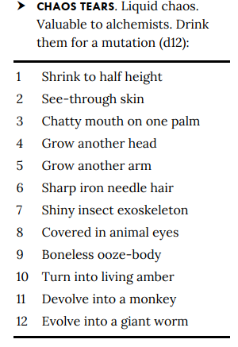
Special Abilities
Cytillesh Stare [◆ or ⟳] (concentrate, incapacitation, mental, visual); Frequency once per round; one target within 30 ft makes a DC 21 Will save. Fail: confused 1 round. Crit fail: confused 1d4 rounds.
Dero Medicine [◆] (healing, manipulate); Heals 45 (7d8+15) HP, but target gains weakness 5 slashing for 1 hour and can’t benefit again until then.
Detonation Toss [◆] (bomb, mutagen, arcane, manipulate); Throws a potion bomb into a square within 30 ft. It explodes in a 10-ft burst, DC 21 Reflex save or suffer a random effect (d6, lasts 1 minute):
- Sleep: Until wakened.
- Poisoned: Enfeebled 3.
- Petrify: Clumsy 3.
- Fire: Burn 1d6.
- Rage: Spend next turn attacking ally.
- Chaos Acid: Melt into a hybrid of the last two creatures you touched (or, if too difficult, the last two creatures the PC fought).
Chaos Tainted Landmine Toss [◆◆] (bomb, fire, manipulate); Throws a mine into a square within 30 ft. It explodes at start of his next turn or when entered: 28 (8d6+5) fire damage in 10-ft burst, DC 21 Reflex save (half on success, double + prone on crit fail).
A PC that takes any damage from this attack should also make a DC 21 Fort save as the s/he is also exposed to chaos taint. See the Chaos Tears table. These effects only last 1d4 turns or a remove curse or powerful healing magic can restore the creature. Not so if anyone drinks the Chaos Tear.
Summon Pyrebound Servants [◇] (occult, fire, conjuration); Once per day, summons 2 × greater fire elementals (level 11 each) for 1 minute.
Tactics
- Before Combat: Cast haste on self and summon his elementals.
- During Combat: Opens with Landmine Toss, follows with confusion or synaptic pulse. Summons elementals if pressured.
- Morale: Teleports away if below 50 HP.
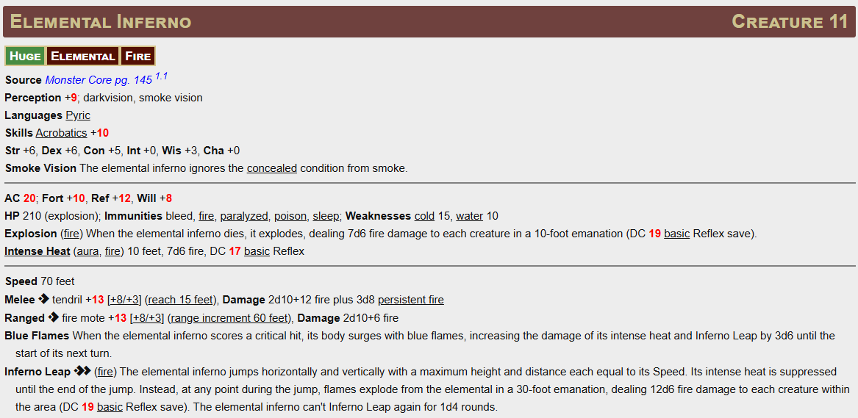
The derro may summon two fire elementals to aide him:

Bomb Assembly Hazard 16
Level 16 Mechanical Hazard
Complex, Trap, Mechanical
Stealth +11 (expert) (DC 21 to notice before activation. An inventor may use Crafting skill to notice instead of Perception)
Description A cluster of automated launch tubes that churn out unstable walking bombs at intervals.

Disable DC 21 Thievery (expert) to jam the conveyor belts, or DC 21 Arcana to disrupt the control glyphs. Both require 2 successful checks.
An inventor may use Crafting check instead at DC 21 disabling the device in 1 successful check by pressing “the big red button”.
Destroying the assembly (Hardness 20, HP 80, BT 40) also disables it.

AC 21; Fort +11, Ref +9
Hardness 20, HP 80 (BT 40); Immunities critical hits, object immunities, precision damage
Reset The assembly self-repairs on a 1 in 1d4 but is deactivated at least for 1 round.

Routine (1 round)
On initiative count 20 (losing ties), the bomb assembly ejects a Walking Bomb into an adjacent square.

Walking Bomb Creature 6
CE Uncommon Small Construct Robot Minion
Perception +8; darkvision
Languages understands Common
Str +3, Dex +2, Con +0, Int –3, Wis +1, Cha –2
AC 18; Fort +9, Ref +8, Will +6
HP 1; Immunities poison, death effects, paralyzed, unconscious; No damage on a failed saving throw.
Death burst When destroyed, explodes in a 15-foot burst, DC 22 basic Reflex. Damage 28 (8d6) fire and force.
Speed 25 feet
Melee [◆] Detonate When it comes within 5 feet of a creature, it explodes, explodes in a 15-foot burst, DC 22 basic Reflex. Damage 28 (8d6) fire and force. The Walking Bomb is intelligent and will maximize its detonation range without affecting Mekengineer Thermaplugg

⚙️Mekengineer Thermaplugg CR 20
LE Uncommon Medium Humanoid Gnome Inventor Mythic
Perception +33; darkvision
Languages Common, Gnomish, Undercommon
Skills Arcana +34, Crafting +36, Deception +31, Engineering Lore +36, Intimidation +33, Stealth +30
Str +6, Dex +4, Con +7, Int +9, Wis +4, Cha +5
Items Mechanized Armor Innovation, Peacekeeper-grade gauntlets, unstable overdrive core, bomb satchel (6 charges), Big Book of Robots

AC 24 (Juggernaut Frame, heavy armor plating, shield emitters); Fort +13, Ref +10, Will +16
HP 390
Resistances physical 10 (except skymetal; see Armor Overdrive), fire 10, poison 10;
Immunities gloomium; paralyzed, petrified, unconscious
Overdrive Malfunction When Thermaplugg critically fails a Strike, he takes 14 (4d6) fire splash damage as his armor vents dangerously.

Hard to Kill [⟳] Frequency 1/day. Trigger Thermaplugg would be reduced to 0 HP. Effect His armor self-repairs violently, restoring 200 HP and causing him to gain Persistent Fire 20 as sparks consume the frame. When this ability is activated he looses legendary actions until the start of his next turn (ie he goes 1 turn without legendary actions).
Aura — Clanking Dominion (aura, mental, auditory) 30 feet. Allied constructs and robots within the aura gain a +2 circumstance bonus to attack rolls. Enemies must succeed at a DC 24 Will save or be Frightened 1 at the start of their turn. A critical save makes the PC immune to this effect for 24 hours.

Speed 25 feet
Melee [◆] crushing gauntlet +15/+10/+5 (magical, reach 15 feet), Damage 40 (4d10+18) bludgeoning plus 18 (4d6+2) fire
Melee [◆] sawblade fist +15/+10/+5 (magical, reach 15 feet, deadly d12), Damage 46 (4d12+20) slashing plus 14 (4d6) persistent bleed

Ranged [◆◆] unstable cannon ++15/+10/+5 (arcane, gloomium, range 120 feet, once per encounter), Effect The cannon fires an unstable blast. All creatures in a 40-foot line must attempt a DC 24 Reflex save.
- Critical Success: No damage
- Success: 42 (12d12) gloomium and piercing damage
- Failure: 84 (24d12) gloomium and piercing damage
- Critical Failure: Double damage and Sickened 3 (triggering gloomium sickness)

Explosive Venting [◆◆] (fire, manipulate, inventor) Thermaplugg overheats his suit and blasts steam in a 30-foot cone. Each creature must attempt a DC 24 Reflex save.
- Success: 28 (8d6+4) fire damage
- Failure: 56 (16d6+8) fire and gloomium damage and Sickened 1
- Critical Failure: Double damage and Sickened 2
Armor Overdrive [free-action] (inventor, manipulate) Frequency once per 10 minutes. Thermaplugg supercharges his armor, gaining +10-foot Speed, +2 AC, and resistance 15 physical for 1 minute. At the end, his suit locks up, making him Slowed 1 for 1 round.
Bomb Deployment [◆◆] (manipulate, fire, arcane) Thermaplugg tosses a bomb from his satchel into a 15-foot burst within 60 feet. All creatures must attempt a DC 24 Reflex save.
- Success: Half of 31 (9d6+5) gloomium and piercing damage
- Failure: Full damage
- Critical Failure: Full damage + Persistent Fire 4d6
Judgment of Gnomeregan [◆◆◆] Thermaplugg makes two gauntlet Strikes and one sawblade Strike, in any order. These do not incur multiple attack penalties.

Legendary Actions
Thermaplugg can take 3 legendary actions per round, only one per turn.
- Clanking Swipe: Thermaplugg makes one gauntlet Strike.
Roll | Bomb  Assembly
1 | W
2 | E
3 | NE
4 | NW
5 | SE
6 | SW
- Deploy Gizmo Mine (1/round) Toss a mine in an adjacent square. At the start of Thermaplugg’s next turn, it detonates for 22 (6d6+5) gloomium damage in a 10-foot burst (DC 24 Reflex basic save).
- Emergency Patchwork (1/round) Thermaplugg welds his armor, regaining 50 HP.

Lair Actions
On initiative count 20 (losing initiative ties), the mad mekgineer takes a lair action to cause the following effect.
Activate Bomb Assemblies. Roll from the table below (1 roll per 2 characters rounding up). The corresponding bomb assembly activates (roll for its own initiative) or are no longer Incapacitated.

🧠 Mekgineer Thermaplugg
(Tone: unhinged genius, part Bond villain, part mad gnome, with Wonderland-style self-awareness)
- “Welcome to my masterpiece! I call it… You Losing!”
- “Every explosion is a love letter to science.”
- “You’re witnessing genius! Too bad it’s the last thing you’ll ever see.”
- “When the history books are written, they’ll say: ‘He laughed maniacally… then everything blew up.’”
- “I built this entire city to spite you personally!” (mid-fight escalation)
👉 Thermaplugg benefits from having a monologue line at 50% HP — something theatrical before unleashing a big ability.

Treasure

💠 Harvest Soulstone Item 8
Magical, Divination, Occult (or Primal, if you prefer a druidic flavor)
Usage held in 1 hand; Bulk L; Price 450 gp
This glowing blue crystal hums softly when held, its interior swirling with faint images of forests, ruins, and stars. The soulstone contains the memories of an ancient being that once walked the land. When tapped into, its spectral intelligence provides answers about the world—but doing so drains the user’s vitality.

✨ Activate — Consult the Soulstone [two-actions] (concentrate, mental)
Frequency once per 10 minutes
Effect You ask the soulstone a question related to Nature or History. The soulstone casts legend lore (GM’s discretion) in a limited fashion: it provides a brief, accurate answer as though a creature with Nature +20 or Lore (History) +20made a Recall Knowledge check.
You immediately gain the Fatigued condition as your life force is drawn into the crystal.
The soulstone refuses questions outside its domain (e.g., planar travel, arcane formulae).

Electrocutioner’s Leg (Unique Weapon) Item 15
Unique +2 greater striking rapier; Traits: Electricity, Evocation, Magical
Usage 1 hand; Bulk 1; Rarity Rare; Invested No
- The blade constantly hums with charge. It deals an additional 1d6 electricity damage on each Strike.
- Surge on Crit ⟡ effect: On a critical hit, the target must attempt a DC [Class] Fortitude save.
  - Crit Success: No effect.
  - Success: Target is stupefied 1 until the end of its next turn.
  - Failure: Target is stunned 1.
  - Crit Failure: Target is stunned 2.
- Frequency The Surge effect can apply only once per round per target.
- The weapon counts as a rapier for all purposes.

Source (5e item reference on the Treasure page). GM Binder

Grubbis’ Protective Pail Item 15
Worn head item; Traits: Abjuration, Magical; Usage worn; Bulk L; Rarity Rare; Invested Yes
- You gain resistance 7 to bludgeoning damage.
- Mine-Hardy: Against falls, cave-ins, or collapsing debris, your resistance increases to 15.
- Sealed Rim: You gain a +2 item bonus to Fortitude saves against inhaled poisons and environmental particulates (smoke, dust, industrial fumes).

Source (5e item reference on the Treasure page). GM Binder

Hydrocane Item 15
Wand/rod-like staff; Traits: Water, Evocation, Magical; Usage 2 hands; Bulk 1; Rarity Rare; Invested Yes
- Aquatic Adaptation (constant while invested): You gain a swim Speed 30 feet and can breathe water and air.
- Activate ◈◈ command, manipulate — Tidal Authority
  - Effect: Cast control water at 7th rank (item DC 34, or your class DC if higher). Frequency 1/day.
- Activate ◈ command, manipulate — Hydraulic Blast
  - Effect: Cast hydraulic push at 6th rank. Frequency 3/day.
- Activate ◈ command, manipulate — Water Walkers
  - Effect: Cast water walk at 5th rank affecting you and up to 5 creatures you touch. Frequency 1/day.

Source (5e item reference on the Treasure page). GM Binder

Manual Crowd Pummeler (Unique Weapon) Item 15
Unique +2 greater striking maul; Traits: Evocation, Magical, Shove; Usage 2 hands; Bulk 2; Rarity Rare; Invested No
- This overbuilt fist-on-a-stick hits like a jackhammer.
- Pummeler Routine ◈◈ attack, flourish
  - Requirements: You’re wielding the Manual Crowd Pummeler.
  - Effect: Make up to three Strikes, each against a different creature in your reach. Each Strike takes a –2 circumstance penalty; apply MAP normally across them.
  - After the Routine, you’re off-guard until the start of your next turn.
- On any turn you hit at least two different targets with the Routine, you can Attempt to Shove one of those targets as a free action (no MAP).
Source (5e item reference on the Treasure page). GM Binder

Mecha-Bond Imprint Matrix Item 15
Handheld gadget; Traits: Auditory, Emotion, Enchantment, Magical, Mental; Usage held in 1 hand; Bulk L; Rarity Rare; Invested No
Activate ◈◈◈ command, manipulate — Imprint Construct
- Target: A non-unique construct of level 10 or lower within 30 feet that can see or hear you.
- Effect: Attempt a Crafting check vs. the target’s Will DC.
  - Critical Success: For 1 hour, the construct becomes your minion (it follows PF2e minion rules, acts on your initiative after you, and obeys your commands to the best of its ability).
  - Success: As above, but for 10 minutes.
  - Failure: No effect; you can’t target that construct again for 24 hours.
  - Critical Failure: The construct becomes hostile toward you for 1 minute (GM’s discretion).
- Frequency: 1/hour. A creature that has been successfully imprinted by you can’t be imprinted again for 24 hours.
- If you ever critically succeed against a construct that is already friendly to you, the duration becomes 24 hours instead.

(Built to echo the page’s bonding collar concept but scaled for level-15 play.) Source (5e item reference on the Treasure page; bonding rules text nearby). GM Binder+1

Thermaplugg’s Right Arm Item 15
Worn gauntlet; Traits: Electricity, Fire, Evocation, Magical, Tech; Usage worn on 1 hand; Bulk L; Rarity Rare; Invested Yes
- The arm has 4 charges that recharge each day during daily preparations.
- Unstable Systems: When you Activate the arm, you can try to control which weapon fires.
- Activate ◈◈ command, manipulate — Overclock Armament
- Effect: Attempt a DC 24 Crafting check. On success, choose one effect below; on failure, roll randomly; on critical failure, roll randomly, and you also become off-guard until the start of your next turn. Each use costs one charge unless stated.
- Static Discharge (Aura) — Emanation 10 feet, 6d6 electricity damage to creatures in the area (including you); Basic Reflex DC (Class). Costs an extra charge on failure to control (total 2 charges).
- Steam Blast (Cone) — 30-foot cone, 10d6 fire, Basic Reflex DC (Class); creatures that fail are pushed 10 feet.
- Welding Beam (Line) — 120-foot line, 12d6 damage (6d6 fire + 6d6 electricity), Basic Reflex DC DC (Class).
- Bomb Launcher — Create two walking bomb minions in empty squares within 30 feet. They detonate at the end of your next turn (GM can use standard clockwork bomb minion stat blocks; treat each as a level-10 disposable minion that Detonates for 6d6 fire + 6d6 piercing in a 10-foot burst, Basic Reflex DC DC (Class)).
- Safety Interlocks: If you use the arm two or more times in the same encounter, you take two persistent electricity damage (this stacks) until the encounter ends or the arm is inactive for 1 minute.

Source (5e item reference on the Treasure page; also referenced after the Thermaplugg fight text). GM Binder+1

🛠 Operation: Gnomageddon
📌 Legend
Icon | Meaning
☢️ | Radiation present (persistent or event-based). DC 14 Fortitude save. On a fail become sickened 1. This can’t be removed while in Gnomageddon. DC increases by 1 each time you see this symbol.
⚔️ | Hostile encounter, random encounter or monsters present
💀 | Major boss or named enemy
📜 | Quest objective, mission-critical, or narrative set piece
🧠 | Puzzle, trap, or interactive hazard
🛠️ | Engineering/mechanical zone (environmental dangers or important terrain)
🎲 | Random encounter check (1 in 6 chance). Ask the DM what you encounter.
⚠️ | Hazard (usually environmental)

1 – Upper Gnomeregan☢️ ⚔️
Once a shining hub of invention, Upper Gnomeregan is now a warzone. The old train depot that once linked to Ironforge lies shattered. Decontamination crews and S.A.F.E. troops fight to reclaim the halls, while leper gnomes cling desperately to their stolen kingdom. Alarms echo faintly through the steel corridors, half-muted by the heavy air.

1A – Entrance⚔️ 🛠️
➊ First Entry
A colossal gear-shaped gate dominates the mountainside. Armed gnomish soldiers stand at attention, their weapons humming softly, eyes scanning for any sign of contamination or enemy spies. Beyond, a long metal ramp descends into the mountain’s heart.
As you step inside, the air grows colder. A massive piston chamber awaits below; with a thunderous clunk, the elevator platform rises to meet you. When it descends again, it carries you deeper into the reclaimed upper levels.

🔁Return Visit
The guards eye you with curt nods. The gate’s gears turn slowly, their grinding echo filling the metal corridor.

1B – Loading Rooms☢️ 🛠️
➊ First Entry
The elevator opens into a blinding wash of sterilizing spray. Gnomes in sealed suits man floor-mounted cannons, blasting any trace of radiation away. Sanitron 600 drones drift overhead like fat silver bees, misting disinfectant in lazy arcs.
Beyond lies a makeshift field hospital. Gnome medics race between cots, tending to the pale and trembling victims of fallout. The sharp smell of antiseptic and burnt metal fills the air. Guards stand watch by the northern door, demanding writs from the High Tinker to pass.

🔁Return Visit
The drones hover lazily now, their tanks half-empty. A medic gives a weary nod as you pass through the disinfectant fog once again.

1C – Clockwork Run⚔️ 🛠️
➊ First Entry
The corridor opens onto a narrow L-shaped platform overlooking dead tram tracks far below. Gnomish troops have turned it into a forward outpost — sandbags, turrets, and improvised barricades form a thin line of defense. Commanders point west toward a partially collapsed tunnel leading deeper, warning you to avoid the north. The train depot, they say, is still a killing ground.

🔁Return Visit
The soldiers look more tired now. A turret swivels slowly, following unseen movement in the dark beyond.

1D – Train Depot☢️ ⚔️ 💀 🛠️
➊ First Entry
The train depot is a blasted cavern of twisted steel and smoke. Thermaplugg’s leper gnomes surge against S.A.F.E. lines in endless waves, their screams mingling with the roar of gunfire and grinding machinery. Bodies and shattered constructs litter the floor. The central pillar, a strategic prize, is scorched from countless assaults. The air thrums with violence; this is no place for hesitation.

Battlefield Event
A fresh wave crashes against the barricades — sparks, shouting, and gunfire drown out everything else.

☢️ Radiation present: DC 14 Fortitude save. On a failure become sickened 1. This can’t be removed while in Gnomageddon. DC increases by 1 each time you see this symbol. Resets each time the PC gets to sickened 3 or leaves Gnomegeddon.

1E – Workshop Entrance🛠️ 🧠
➊ First Entry
The tunnel ends at a towering steel door sealed with no obvious handle. Its surface is smooth and cold, humming faintly with hidden mechanisms. Somewhere nearby, a faint click echoes, hinting at the concealed release. Beyond this barrier lies the deeper heart of Gnomeregan.

Requires the workshop key or the access code (see area 6 – Engineering Lab)

🔁Return Visit
The air here is still and heavy. The massive door looms in silence, waiting for a hand clever or strong enough to open it.

2 – The Hall of Gears☢️ ⚔️ 🛠️
Once the grand entryway to Gnomeregan, the Hall of Gears is now a broken colossus. The upper levels crawl with troggs, while below, radiation pools like stagnant water. The gears still grind — some smooth, some shattered — echoing through the vast chamber like the heartbeat of a dying machine. Reclaiming this hall means purging the troggs and cleansing the toxic depths.

2A – Entry Tunnel⚔️ 🛠️ 📜 🎲
➊ First Entry
Bright spotlights blaze off the polished metal walls of the high, semi-circular tunnel. Automated cranes and conveyors clatter overhead, still faithfully working, oblivious to the war below. The metallic echoes feel both alive and abandoned.
Amidst the noise stands a gnome in commando gear, his stance confident despite the chaos — Murd Doc of the G-Team. His voice cuts through the din: “You’re late. But we’ll make commandos of you yet.”

🔁Return Visit
The machinery drones on. Murd Doc gives you a curt nod, already focused on the next fight.

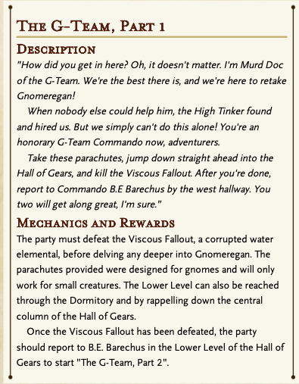
📜 Quest: The G-Team, Part 1
Murd Doc deputizes the party as honorary G-Team operatives. He issues parachutes and a mission: jump into the Hall of Gears and defeat the Viscous Fallout, the corrupted elemental that festers below. Once it’s destroyed, the team must report to Commando B.E. Barechus in the Lower Level to continue the campaign.
“Kill the elemental. Make it clean. And don’t forget to say hi to Barechus on your way down.”
Parachutes only work for small small sized creatures. Medium creatures just fall and take 30 damage.

☢️ Radiation present: DC 14 Fortitude save. On a failure become sickened 1. This can’t be removed while in Gnomageddon. DC increases by 1 each time you see this symbol. Resets each time the PC gets to sickened 3 or leaves Gnomegeddon.

🎲Random Encounter. Roll a 1d6, on a 1 there is an encounter: 1-2 Irradiated Trog Troop (*1d4), 3-4 random ooze (1-2 Irradiated Horror (*1d6), 3-5 Irradiated Slime (*1d4), 6 Unique, see Viscious Fallout Lair Action)

2B – Upper Level☢️ ⚔️ 🛠️ 🎲
➊ First Entry
The Entry Tunnel spills onto a vast circular platform clinging to the walls of a chamber the size of a cathedral. Overhead, titanic gears turn and groan, some frozen mid-bite, others grinding like dying beasts. The central column leans drunkenly, spotlights cutting narrow beams through hanging mist. Far below, the Lower Level vanishes into green fog.
Tunnels branch in every direction — to trogg-infested warrens, a beleaguered Clean Zone, and dormitories now in enemy hands. Trogg warbands patrol the perimeter, their guttural growls echoing up the walls.

🔁Return Visit
The machinery’s rhythm grows almost familiar, but the trogg presence has not diminished. Their shadows flicker in the mist.

☢️ Radiation present: DC 14 Fortitude save. On a failure become sickened 1. This can’t be removed while in Gnomageddon. DC increases by 1 each time you see this symbol. Resets each time the PC gets to sickened 3 or leaves Gnomegeddon.

🎲Random Encounter. Roll a 1d6, on a 1 there is an encounter: 1-2 Irradiated Trog Troop (*1d4+1), 3-4 random ooze (1-2 Irradiated Horror (*1d6), 3-5 Irradiated Slime (*1d4), 6 Unique, see Viscious Fallout Lair Action)

2C – Trogg Tunnels ⚔️ ☢️ 🧠 📜 🎲
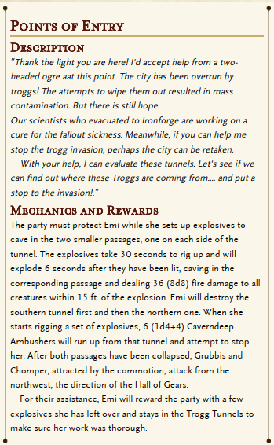
➊ First Entry
An alarm light still blinks over the metal-plated entrance, bathing the tunnel in angry red. Further in, the steel gives way to rough-hewn walls. The floor is slick with looted debris and charred trogg remains. Smoke curls lazily from the corpses.
At the junction, a wild-eyed gnome is rifling through crates — Blastmaster Emi Shortfuse, explosives expert and proud survivor. She glances up with manic energy: “Finally! Help. I’ve got tunnels to collapse.”

📜 Quest: Points of Entry
Emi enlists the party to seal the trogg invasion tunnels. She’ll rig explosives while the heroes hold off waves of attackers. If they succeed, both tunnels collapse, cutting off the trogg flow. Their efforts will draw out Grubbis and his basilisk, Chomper, for a climactic fight.
“Watch my back while I rig these charges. When this goes up, the troggs’ll have nowhere left to run — except straight into us.”

⚔️Event — Grubbis and Chomper
As the echoes of the blasting charges fade, a deep rumble grows. A massive trogg lumbers into view, a basilisk at his side. Grubbis bellows, “We come from below! You can never stop us!”
When Grubbis is defeated, the party may loot Grubbis' Protective Pail.
☢️ Radiation present: DC 14 Fortitude save. On a failure become sickened 1. This can’t be removed while in Gnomageddon. DC increases by 1 each time you see this symbol. Resets each time the PC gets to sickened 3 or leaves Gnomegeddon.

🎲Random Encounter. Roll a 1d6, on a 1 there is an encounter: 1-2 Irradiated Trog Troop (*1d4+1), 3-4 random ooze (1-2 Irradiated Horror (*1d6), 3-5 Irradiated Slime (*1d4), 6 Unique, see Viscious Fallout Lair Action)

2D – Tin Templar ⚔️ ☢️ 🧠 📜 🎲
Stone tiles cover the floor. Iron panels cover the walls and ceiling. An iron coffin rests on the ceiling. Three bronze levers are set into the far wall. The room hums.

🧲 PANELS. Powerful magnets. Control all metal in the room, including people in armor. (See levers.)
⚰️ COFFIN. Held up magnetically. Cannot be opened on the ceiling. Contains the rusty corpse of Tristan the Tin Templar (hero of Law). When the coffin opens, the templar is horrifically reanimated by the gloomium infused magnetic fields, and rampages!
🎚️ LEVERS. All three are currently up, and all iron objects (weapons, armor, etc.) are pulled upward. Settings:
- Any one lever down: metal objects are hurled north (10 hp damage).
- Any two levers down: metal objects are hurled south (10 hp damage).
- All three levers down: metal objects are gently lowered (opens coffin).

☢️ Radiation present: DC 14 Fortitude save. On a failure become sickened 1. This can’t be removed while in Gnomageddon. DC increases by 1 each time you see this symbol. Resets each time the PC gets to sickened 3 or leaves Gnomegeddon.

3 – The Clean Zone🛡️ 🛠️ 🎲
➊ First Entry
Barricades of overturned furniture and scavenged scrap choke both entrances. From behind them, tired gnome warriors raise their weapons, eyes sharp despite exhaustion. After tense moments and a few pointed questions, they relax—troggs and lepers you are not. The barricades part to reveal a fragile island of order in the chaos.
Inside, wounded soldiers lie on makeshift beds while haunted medics work with dwindling supplies. Technicians strip metal from the walls to patch weapons and armor. At the center stands Tink Sprocketwhistle, once a merchant prince, now using the last of his wealth to keep his people alive. The Clean Zone is a haven—but only barely.

🔁Return Visit
The guards recognize you with grim nods. The barricades are sturdier now, the mood no less tense.

🎲Event – Attack on Clean Room 42.
Roll a 1d6 each time the PCs visit or take a Long Rest – 1-3 No Encounter, 4 1d4+1 troggs attack, 5 1d4 Leper Gnome Attack (1 in 4 chance of having supporting mech units, 6 Irradiated oozes leak through the rooms plating

🧠 Special Feature — The Sparklematic 5200
Set into the north and south walls are two spotless machines, their chrome casings gleaming against the battered room. Each bears a cheerful plaque:
“Grime and residue ruining your sparklies? The Sparklematic 5200 puts the shine back in shine-tastic!”
Insert a grime-encrusted object and three silver coins, and the contraption clatters to life. Moments later, something unexpected tumbles out. (1-4 oddity, 5 cypher, 6 Yellow Punch Card)
Whenever a creature in Gnomeregan is looted, there’s a 50% chance (11+) to find a grime-encrusted object suitable for the machine.

4 – The Dormitory⚔️ ☢️ 🧠 🎲
➊ First Entry
The raised walkway dips into a broad recessed chamber buried under debris and trash. The air is thick with the stench of troggs. Below, two filthy gangs snarl and shove at each other over a twisted scrap of useless machinery — their crude weapons catch the harsh light as tensions mount.
The southern and eastern walls slope sharply outward, alcoves carved high into the metal like gaping mouths. Each alcove holds a sealed door leading to once-orderly living quarters, now sealed behind grime and time.
Exits lead west to the Clean Zone barricade and north toward the Lower Level, though an iron partition blocks direct sight. Built into this offset wall is a Matrix Punchograph 3005-B, its panel blinking expectantly.

🔁Return Visit
The trash has shifted, the stench no less pungent. The sound of distant trogg arguments echoes from unseen alcoves.

Dorm Room Contents
West Room South Wall (locked DC 13). The room is mostly empty except for the body of a gnome covered in burns. Stuffed in his mouth is a report authored by a "Kernobee" detailing a secret alliance between the Derro and Mekgineer Thermaplugg. The document also contains schematics of Thermaplugg's Bomb Assembly machines. Anyone who has this schematic has advantage on the Big Red Button Intelligence check.
East Room South Wall (locked DC 30, Cannot be opened by magical means). Outside of the door is a Matrix Punchograph 3005-E built into the wall. Inserting a Prismatic Punch Card will open the door. Inside is the Sentient Mechanostrider. He is friendly to the party, but will refuse to leave the room unless compelled to do so by the Mecha-Bond Imprint Matrix. He is a robot version of the Fat Chocobo.
South Room East Wall (DC 15). This room is filled with dense radiation. All creatures within 15 ft. of the door when it is opened must succeed on a DC 21 Fort saving throw or take 16 (3d10) poison damage and are sickened 1 until their next short or long rest. The door is hot to the touch.
North Room East Wall (Unlocked). This room is currently occupied by a group of sleeping troggs. There is also a small collection of 4 (1d8) Grime-Encrusted Objects arranged in an aesthetically pleasing manner.

🧠 Special Feature — Matrix Punchograph 3005-B
The iron wall’s inset device flares to life when touched. Lines of green text scroll across a flickering screen:
“Please insert Yellow Punch Card.”
Feeding in the Yellow Punch Card triggers a series of mechanical whirs. Moments later, the machine ejects a Blue Punch Card with a metallic shhk! sound. The way north then lies open.

☢️ Radiation present: DC 14 Fortitude save. On a failure become sickened 1. This can’t be removed while in Gnomageddon. DC increases by 1 each time you see this symbol. Resets each time the PC gets to sickened 3 or leaves Gnomegeddon.

🎲Random Encounter. Roll a 1d6, on a 1 there is an encounter: 1-4 Irradiated Trog Troop (*1d4+1), 5 random ooze (1-2 Irradiated Horror (*1d6), 3-5 Irradiated Slime (*1d4), 6 Unique, see Vicious Fallout Lair Action)

5 – Launch Bay☢️ ⚔️ 🛠️ 💀 🎲
➊ First Entry
Once the pride of Gnomeregan’s skies, the Launch Bay now groans under the weight of Thermaplugg’s war machine. Leper gnome engineers swarm like ants, gutting aircraft to forge engines of war suited for underground conflict. Sparks flash. Alarms hum. Somewhere deeper inside, something big is waking up. What the gnomes were planning to do with an airforce so deep underground is anyone’s guess.

5A – Irradiated Tramway☢️ ⚔️ ⚠️ 🎲
➊ First Entry
The long tunnel reeks of ozone and stagnant water. Bright spotlights stab at the darkness, revealing rusted rails drowned beneath glowing, irradiated pools. Flickering wires dangle overhead. Here and there, half-buried landmines lie forgotten. Every step on the lower track crackles with risk.
A raised southern platform offers safer footing, but not safety — leprous patrols march their beat, Mechanized Sentries whirring beside them. At the western terminal, the silhouette of a half-built spider tank looms like a dead sentinel.

🔁Return Visit
The lights flicker more now. A distant mine clicks somewhere in the dark.

⚠️ Hazards
When a creature enters or starts its turn on the lower tram track, roll on the Hazard Table for effects: mines, radiation bursts, or livewires. Each danger is as sudden as it is deadly.
☢️ Radiation present: DC 14 Fortitude save. On a failure become sickened 1. This can’t be removed while in Gnomageddon. DC increases by 1 each time you see this symbol. Resets each time the PC gets to sickened 3 or leaves Gnomegeddon.

🎲Random Encounter. Roll a 1d6, on a 1 there is an encounter: 1-4 Leper Gnome Force (x1d4+1), 5 Leper Gnome Force (x1d4) and 1x Lepere Mechanized Force, 6 Unique ooze, see Vicious Fallout Lair Action)

5B – Flight Decks⚔️ ☢️ 🛠️ 💀 🎲
➊ First Entry
The Flight Decks ring the Launch Bay like a steel halo, 50 feet above the floor. Spotlights blaze inward, converging on a central circular platform suspended in the middle of the chamber. Around the decks, dismantled aircraft lie in pieces. Leper gnomes scramble across catwalks, hauling parts into the tunnels.
Far ahead, a massive mechano-tank, the Electrocutioner 6000, stands silent but sparking atop the central platform. From this vantage, its pilot surveys the bay like a king on a throne of lightning. A narrow metal bridge stretches between the decks and the platform — the only way across.

🔁Return Visit
The air hums with static. The platform stands scorched from past battles, its bridge slick with oil and blood.

🧠 Special Feature — Matrix Punchograph 3005-C
A panel on the platform lights up when approached. Text scrolls across the display:
“Please insert Blue Punch Card.”
Inserting the card triggers a hiss of pneumatics, and the device spits out a Red Punch Card. A crate of small-sized parachutes sits nearby, clearly meant for gnome paratroopers — or creative adventurers.

💀 Boss — Electrocutioner 6000
A sparking monstrosity of Thermaplugg’s impatience, this supercharged mechano-tank is piloted by Lieutenant Tom “Sizzlepants” Crankle, a leper hero. From the platform’s center, it unleashes lightning, blades, and terror.
“Electric Justice!”
When destroyed, the party can recover Electrocutioner’s Leg and the Workshop Key, both critical for later progress.

5C – Maintenance Tunnel A⚔️ 🧠 ☢️ 🎲
➊ First Entry
Narrow walls press in on all sides. Steam hisses from overhead pipes. Pressure vats thrum like mechanical hearts. Shadows move behind recessed panels — the perfect place for an ambush.
This tunnel winds between the Flight Decks and the Lower Level, branching southwest toward the Engineering Labs.

⚔️Event — Ambush
Hidden panels slide open with a metallic shriek. Leper gnome soldiers and a Mechanized Guardian burst forth, attempting to catch intruders in the choke point. The leper gnomes will come from behind as the PCs engage the Bronze Butcher.

⚙️5C-1 Hall of Swords (Level 13 Moderate)
[20 ft. × 80 ft. corridor connects Launch Bay (Bottom) to Engineering (Top)]
A cold puddle fills the entrance of this dim passage. Racks of swords line the walls. Wires crisscross the room at ankle height. Floor tiles rest at odd angles. Halfway down, a heap of metal lies on the floor. A voice whispers from above.

🌊 PUDDLE. 20x20. Ankle-deep, cold, river water (DC 17 Reflex or make a loud splash).
🗡️SWORDS. Bronze, curvy (d6).
🪢WIRES. Tied to swords. Tripping causes a few swords to clatter loudly to the floor, waking the Bronze Butcher.
🧱 TILES. Crooked tiles hide glass vials of poison gas that cause loud coughing fits, waking the Bronze Butcher.
⚔️HEAP. Fifty bronze swords in a loose pile. When touched, they shudder and combine into the hulking Bronze Butcher.
🦋VOICE. Glim the pixie gives bad advice for fun: “Ignore the tiles! Just pluck the wires!”
🗝️SECRET. Behind a sword rack lies an Gnomish Burst Crossbow (DC 17 Perception).

💰🗝️ Treasure — Gnomish Burst Crossbow
+2 Greater Striking Heavy Crossbow; Burst Mode (2 actions): 20-ft. line, Basic Reflex save 6d8 piercing; Reload: 3 actions. 1-in-6 chance to jam each time, requiring 3 actions to fix.

🦋 Ascala the Glitch Feary
Use a pixie with and add the Glitch traits; Ascala doesn’t fight but gives misleading advice like:
“Ignore the tiles! Just push the wires!”
She isn’t inherently evil (CN) can act as a scout or trap lure if needed. She can suppress her aura as well:

Glitch [aura] (abjuration, aura, curse, magical, misfortune, incapacitation) 10 feet
Antimagic Suppression Within the aura, spells, magic items, and magical effects are suppressed as if in an antimagic field. Use the glitch faerie’s spell DC for counteract DCs; the aura’s counteract rank equals the faerie’s level (or its highest spell rank, if any), and the aura’s counteract modifier is the faerie’s spell DC − 10. Suppressed effects resume when leaving the aura.
Jittering Aim Creatures other than the glitch faerie within the aura have misfortune on attack rolls (roll twice, use the lower result). This misfortune ends immediately when the creature leaves the aura. This is a misfortune effect and doesn’t stack with other misfortune.
Glitch Curse [two-actions] (abjuration, auditory or visual, curse, incapacitation, magical, mental) Range 30 feet; Targets1 creature
The glitch faerie hexes a foe’s gear with unseen sabotage. The target must attempt a Will save against the glitch faerie’s spell DC.
- Critical Success The target is unaffected and is temporarily immune to Glitch Curse for 24 hours.
- Success The target is unaffected.
- Failure Until the end of the next 24 hours, the next time the target uses or activates a technological device, the device glitches: the activation fails, any charges or consumables are expended, and the device gains the brokencondition for 1 minute (or until repaired).
- Critical Failure As failure, and the device overloads, dealing 4d6 electricity damage to the user (basic Reflex save against the same DC). The device remains broken until repaired (Repair check as normal for the item; GM sets DC).

Bronze Butcher - Awakening Trigger
The Butcher lies dormant as a heap of bronze swords. Any noise or disturbance from the hazards causes it to animate.

🪼Maintenance Shaft B (Secret Door, DC 20 Craft, DC 24 Perception)
[Connects Launch Bay (bottom) to Tinker’s Court (secret door)]
Metal stairs spiral down and stop at a steamy abyss. Shining metal platforms float in the darkness with tiny blue lights glimmer all around.
🌌 ABYSS. Looks bottomless. There is steamy water 20 feet below.
🧱 PLATFORMS. Eight, hovering, do not move. Each holds one person. Jump across to reach solid ground. Each contains one sapphire (25g), but when removed the platform falls and every frogga game now starts with a shorter timer. PCs individually play Frogga to get across. Trying to fly over or bypass it in anyway the electrocution is so great the PC loses 1d6+1 healing surges.
🪼 LIGHTS. Vast arcflash jellyfish swarm, float in water and air. Falling of the platform inflicts 5 HP of damage and the PC is electrocuted (white hair and lose a healing surge).

5D – Lower Level🛠️ ⚔️ ☢️ 🎲 📜
➊ First Entry
Unlike the rest of the Launch Bay, the lower chamber gleams — smooth plating lines the walls and floors, reflecting the cycling pistons around the central support column. Above, the platform of the Electrocutioner looms like a thunderhead.
Leper gnome technicians scramble across the floor, trying to assemble defenses from scrap. Their machines hum weakly, half-finished and sputtering.

🔁Return Visit
The rhythmic hiss-clunk of pistons fills the quiet. The chamber feels like a lung at rest.

📜 Quest — The G-Team, Part 3
When the area is secured, Commando Face, the third G-Team operative, emerges from a hidden panel with a grin.
“I’d keep my distance from B.E. Barechus and Murd Doc. Neither’s stable. But you? You’ll do.”
He directs the party onward: through Tinkers’ Way to face Mekgineer Thermaplugg himself in Tinkers’ Court. The time to end the siege draws near.

6 – Engineering Labs🛠️ ⚔️ ☢️ 💀 🎲
This is the beating heart of Thermaplugg’s war machine. Here, mad designs become killing engines. The air hums with power; everywhere you look, pipes, conduits, and machinery churn ceaselessly. Leper gnomes scurry like worker ants, guarding, repairing, and testing. Somewhere deeper, their most dangerous toys lie waiting.

6A – Observation Decks🧠 ⚔️ 🛠️ ☢️ 🎲
➊ First Entry
A square ring of corridors and viewing chambers encircles the Engineering Labs. Through massive interior windows, the Test Chamber below is visible — a tangled nest of machinery and pipes. Along the walls, blinking consoles and gutted devices hum or spark. Discarded parts crunch underfoot.
Leper gnome engineers and guards occupy the western, northern, and eastern rooms, their gaze fixed downward. In the southern room, something far larger looms in the half-light: the Crowd Pummeler 9-60, one of Thermaplugg’s deadliest inventions, dormant but ready.

🔁Return Visit
The smell of ozone lingers. The broken glass and burned circuitry tell of what once stood guard here.

💀 LAB A: Boss — Crowd Pummeler 9-60 (S)
Once an arena champion turned weapon of war, this colossal construct patrols the southern observation chamber. When activated, its only directive is to smash anything Thermaplugg deems an enemy, friend or foe alike. Its thunderous footfalls shake the deck as it charges.
“Pummel mode… engaged.”
When defeated, the party may recover the Manual Crowd Pummeler as valuable loot.

⚔️ 🧠LAB B: Lazy Leper Gnome (N)
Six crates sit neatly against the wall. A small person sits on a crate snoring loudly. A second crossbow sits on another crate.

⚠️ TRAP. A trip wire fires the crossbow on the crate (d8).
📦 CRATES. Full of copper and tin plates, rods, and gears.
🧑‍🔧 PERSON. Tinker Gnome with curly beard and tin hat (Lazella). Pretending to sleep. Hates working. Wears a brass key on a chain.
📝 OPTION. Lazella offers to give the code for SECRET ACCESS TUNNEL if the intruders follow her instructions to assemble the spare parts in the crates. When done, the parts form a windup wolfhound. Lazella hops on it, and they attack with glee!
The PCs will need to make 3 DC 20 crafting checks or DC 24 Intelligence checks to craft the wolfhound. Other leper gnome engineers will turn up each success and fail to watch and cheer and give instructions (use random encounter tables to generate crowd). They will also gleefully attack when the wolfhound is complete.
Lazella carries the blueprint for the wolfhound on her person.

⚔️ 🎲 LAB C & D: Researchers (E & W)
Random encounters are common in the west, north, and east rooms — rotating patrols of constructs and technicians keep watch.

🧠 Navigation
- Northeastern corner: leads deeper into the labs.
- Outward door: Secret Access Tunnel (requires Workshop Key).
- Cargo elevator: descends to the Test Chamber below.

6B – “Secret” Access Tunnel⚔️ 🧠 🛠️ ☢️ 🎲
➊ First Entry
This twisting, narrow passage smells of oil and hot metal. Supplies and damaged war machines line the walls. Leper gnome technicians swarm over broken constructs, trying to wrench them back into the fight above.
Clearing this tunnel severs Thermaplugg’s hidden reinforcement line to the surface — a strategic blow to his defense.

🔒Locked Access Door
This door leads back to the battlefront with the gnomes. In needs the workshop key to open or the code (prime number 2-3-5-7). The wrong code triggers a trap (30 electricity damage).

🧠Event — Supply Line
If not cleared, reinforcements will continue to trickle through this passage during major fights elsewhere in the Labs.

6C – Test Chamber🧠 🛠️ ⚔️ ☢️ 🎲
➊ First Entry
You descend into a towering octagonal chamber. One-way mirrored windows ring the upper walls, watching silently. The central machine is a monstrosity of pipes, coils, and glowing conduits. At its base, the Matrix Punchograph 3005-D waits, display blinking red:
“Please insert Red Punch Card.”
A faint hum fills the room. Beneath the machine sits a blue robotic dog, encased in a shimmering energy shield. Its side is engraved with a single word: K-9.

🧠 Puzzle — K9’s Shield Arrays
Three shield generators are embedded in the outer walls, each accompanied by a panel of light-button sequences. To solve the puzzle you must solve a puzzle box in under 1 minute.

🧠 Alternate – Prime Number Puzzle
Use one of the strips below to simulate the bronze keypad cycling through digits. Read them aloud slowly or display them one at a time. The players must identify and press only primes (2, 3, 5, 7) in the order shown.

Strip 1
4 7 8 2 3 9 5 7
✅ Correct presses: 7, 2, 3, 5, 7
Strip 2
6 5 2 8 3 7 4 2
✅ Correct presses: 5, 2, 3, 7, 2
Strip 3
9 3 5 6 7 8 2 5
✅ Correct presses: 3, 5, 7, 2, 5

K-9 will offer hints via his LED display. For example, he will flash an ‘ which is the mathematical symbol for prime numbers. If the PCs keep pressing less buttons than needed, he will flash the number 5 etc.

Success: Once all three generators are disabled, the shield collapses with a hiss. K9 powers up, yellow eyes glowing, and joyfully runs circles around the chamber, barking mechanically. It ignores the party unless attacked or imprinted with a Mecha-Bond Imprint Matrix.

🧠 Special Feature — Matrix Punchograph 3005-D
Inserting a Red Punch Card causes the machine to emit a deep ka-chunk and eject the Prismatic Punch Card, the final key in the sequence. Prismatic punch card is used to gain access to the Sentient Mechan strider in the dormitory area.

🧭 Exit
A small maintenance hatch in the southwest wall leads into a narrow, pipe-lined tunnel that winds northwest to Tinkers’ Way — the approach to Thermaplugg’s court. Crafting check can also discover this (DC 20) otherwise Perception is DC 24

7 – Tinkers’ Court⚔️ 🛠️ ☢️ 💀 🧠 🎲
➊ First Entry
Once the proud seat of gnomish governance, Tinkers’ Court has become the heart of Thermaplugg’s twisted empire. The once-bright halls now hum with lethal machinery, alliances with mad outsiders, and the unstable genius of a traitor king. Those who reach this place face the full, unrestrained fury of Gnomeregan’s usurper.

7A – Tinkers’ Way⚔️ 🧠 ☢️ 🎲 👁️
➊ First Entry
The tramway slopes steeply downward, flanked by tangled pipes and hanging spotlights that throw cones of dim light and shadow across the corridor. Unlike the irradiated lines above, this tunnel is in unnervingly good condition. Every sound carries.

👁️ Scouting: Two Arcane Nullifier X-21s patrol the tracks in mechanical silence, their nullifying fields crackling faintly. Along the raised southern platform, a Derro emissary and two Mechanized Guardians whisper in conspiratorial tones. Listening carefully reveals their plan: an alliance between the Derro of Blackreach and the Leper Gnomes of Gnomeregan — an unholy pact that could threaten Ironforge itself if left unchecked.

🔁Return Visit
The echo of footsteps and the soft crackle of nullifier fields fill the tramway. The air feels tight, as though the walls themselves are listening.

🎲 Random encounters: Leper patrols and arcane constructs occasionally sweep this tramway, especially if alarms have been raised elsewhere.

7B – Tinkers’ Chambers💀 ⚔️ 🛠️ ☢️ 🧠
➊ First Entry
The tramway spills into a vast circular chamber, once the beating heart of gnomish government. Decorative gears, banners, and delicate mechanisms still cling to the walls, ghostly reminders of better days. Six towering council seats encircle the room, each carved with solemn gnomish visages. Now, they’re anything but ceremonial — each has been refitted into Bomb Assemblies, their innards ticking ominously.
Above the chamber hangs a tangled contraption of coils and capacitors, suspended like a metallic spider ready to strike. Beneath it, on a raised platform, stands Mekgineer Thermaplugg, encased in a hulking robot suit that spits sparks with every movement. His amplified voice booms through the chamber:
“Usurpers! Gnomeregan is mine!”
The air crackles with unstable energy. Machinery begins to whine and shudder. The final battle for Gnomeregan begins.

💀 Boss — Mekgineer Thermaplugg
Murderer, traitor, and self-proclaimed king of the gnomes, Thermaplugg is a genius driven completely mad by ambition. He fights from within a heavily modified mech suit, supported by lethal traps and bomb assemblies. He doesn’t care if the room comes down around him — he’ll burn everything before surrendering.

When Thermaplugg falls, the room goes eerily quiet as the overloaded machinery powers down. Among the debris, the party can recover Thermaplugg’s Right Arm — a final trophy of their victory.

👑7B-1: High Tinkerer’s Quarters
[ 30’ x 30’ bedroom, connected to 7b]
Past tattered blue curtains stands a four-poster bed. In the shadows, small creatures scratch at the floor by an armoire and desk. Sounds of water echo from the back wall.

🛏 BED. Filthy, stained. Gothic horror novels: “Interview with the Necromancer” and “Doctor Gentle and Madame Snide”.
🐔🐢 CREATURES. A few chicken-turtles (colorful feathers, hard shells, harmless) pecking at sunflower seeds.
🧥 ARMOIRE. Items: sack of sunflower seeds, torn silk dresses, moldy velvet suits.

✏️ ✏️ DESK.
Drawers contain 8 unlabeled potion vials (d8), each shimmering faintly under the lab’s flickering lights:
- 🩸 Crimson Draught – The liquid glows faintly when near open wounds. It smells of iron and spring rain. (Heals the drinker — equivalent to a healing surge.)
- 💉 Amber Serum – The mixture shifts colors constantly, as if rejecting itself. Tiny bubbles hiss when exposed to light. (Cures a random mutation or affliction.)
- 🪨 Dust of Stillness – Gray sediment drifts in the vial like powdered bone. A single drop turns to stone if left on the ground. (Petrifies one limb, inflicting Clumsy or Enfeebled 1 until healed.)
- 🐢 Essence of the Shell – Thick and greenish, with a faint scent of pond water. When shaken, it forms a spiral pattern like a turtle shell. (Grow a shell granting +2 AC from behind or become a Grippli.)
- 🐍 Serpent’s Kiss – The liquid moves as if alive, coiling and twisting against the glass. The stopper is sealed with scaled wax. (Transform from the neck down into a sacred Nagaji.)
- 🐒 Simian Brew – Smells of jungle fruit and old tree bark. Tiny handprints form in the condensation. (Grow hand-feet and a prehensile tail — become a Vanara.)
- 🌿 Arbor Rage Elixir – Murky green fluid flecked with moss. The cork is cracked with small roots. (Turns a nearby tree into a raging barbarian or transforms the drinker into a Vegepygmy/Leshy.)
- ⚙️ Living Metal Infusion – Silver fluid with a faint hum. A magnet nearby vibrates when it’s uncorked. (Animates a metal object or transforms the drinker into an Automaton or Android.)

Adding a chaos tear to any of these potions will have an additional effect of creating a random mutation (use The Metamorphica).

🛠 PC — Read-Aloud Script
Icon | Meaning
☢️ | Radiation present (persistent or event-based). DC 14 Fortitude save. On a fail become sickened 1. This cant be removed while in Gnomageddon. DC increases by 1 each time you see this symbol.
⚔️ | Hostile encounter, random encounter or monsters present
💀 | Major boss or named enemy
📜 | Quest objective, mission-critical, or narrative set piece
🧠 | Puzzle, trap, or interactive hazard
🛠️ | Engineering/mechanical zone (environmental dangers or important terrain)
🎲 | Random encounter check (1 in 6 chance). Ask the DM what you encounter.
⚠️ | Hazard (usually environmental)

1 – Upper Gnomeregan☢️ ⚔️
Once a shining hub of invention, Upper Gnomeregan is now a warzone. The old train depot that once linked to Ironforge lies shattered. Decontamination crews and S.A.F.E. troops fight to reclaim the halls, while leper gnomes cling desperately to their stolen kingdom. Alarms echo faintly through the steel corridors, half-muted by the heavy air.

1A – Entrance⚔️ 🛠️
A colossal gear-shaped gate dominates the mountainside. Armed gnomish soldiers stand at attention, their weapons humming softly, eyes scanning for any sign of contamination or enemy spies. Beyond, a long metal ramp descends into the mountain’s heart.
As you step inside, the air grows colder. A massive piston chamber awaits below; with a thunderous clunk, the elevator platform rises to meet you. When it descends again, it carries you deeper into the reclaimed upper levels.

1B – Loading Rooms☢️ 🛠️
The elevator opens into a blinding wash of sterilizing spray. Gnomes in sealed suits man floor-mounted cannons, blasting any trace of radiation away. Sanitron 600 drones drift overhead like fat silver bees, misting disinfectant in lazy arcs.
Beyond lies a makeshift field hospital. Gnome medics race between cots, tending to the pale and trembling victims of fallout. The sharp smell of antiseptic and burnt metal fills the air. Guards stand watch by the northern door, demanding writs from the High Tinker to pass.

1C – Clockwerk Run⚔️ 🛠️
The corridor opens onto a narrow L-shaped platform overlooking dead tram tracks far below. Gnomish troops have turned it into a forward outpost — sandbags, turrets, and improvised barricades form a thin line of defense. Commanders point west toward a partially collapsed tunnel leading deeper, warning you to avoid the north. The train depot, they say, is still a killing ground.

1D – Train Depot☢️ ⚔️ 💀 🛠️
The train depot is a blasted cavern of twisted steel and smoke. Thermaplugg’s leper gnomes surge against S.A.F.E. lines in endless waves, their screams mingling with the roar of gunfire and grinding machinery. Bodies and shattered constructs litter the floor. The central pillar, a strategic prize, is scorched from countless assaults. The air thrums with violence; this is no place for hesitation.

1E – Workshop Entrance🛠️ 🧠
The tunnel ends at a towering steel door sealed with no obvious handle. Its surface is smooth and cold, humming faintly with hidden mechanisms. Somewhere nearby, a faint click echoes, hinting at the concealed release. Beyond this barrier lies the deeper heart of Gnomeregan.

2 – The Hall of Gears☢️ ⚔️ 🛠️
Once the grand entryway to Gnomeregan, the Hall of Gears is now a broken colossus. The upper levels crawl with troggs, while below, radiation pools like stagnant water. The gears still grind — some smooth, some shattered — echoing through the vast chamber like the heartbeat of a dying machine. Reclaiming this hall means purging the troggs and cleansing the toxic depths.

2A – Entry Tunnel⚔️ 🛠️ 📜 🎲
Bright spotlights blaze off the polished metal walls of the high, semi-circular tunnel. Automated cranes and conveyors clatter overhead, still faithfully working, oblivious to the war below. The metallic echoes feel both alive and abandoned.
Amidst the noise stands a gnome in commando gear, his stance confident despite the chaos — Murd Doc of the G-Team. His voice cuts through the din: “You’re late. But we’ll make commandos of you yet.”

2B – Upper Level☢️ ⚔️ 🛠️ 🎲
The Entry Tunnel spills onto a vast circular platform clinging to the walls of a chamber the size of a cathedral. Overhead, titanic gears turn and groan, some frozen mid-bite, others grinding like dying beasts. The central column leans drunkenly, spotlights cutting narrow beams through hanging mist. Far below, the Lower Level vanishes into green fog.
Tunnels branch in every direction — to trogg-infested warrens, a beleaguered Clean Zone, and dormitories now in enemy hands. Trogg warbands patrol the perimeter, their guttural growls echoing up the walls.

2C – Trogg Tunnels ⚔️ ☢️ 🧠 📜 🎲
An alarm light still blinks over the metal-plated entrance, bathing the tunnel in angry red. Further in, the steel gives way to rough-hewn walls. The floor is slick with looted debris and charred trogg remains. Smoke curls lazily from the corpses.
At the junction, a wild-eyed gnome is rifling through crates — Blastmaster Emi Shortfuse, explosives expert and proud survivor. She glances up with manic energy: “Finally! Help. I’ve got tunnels to collapse.”

3 – The Clean Zone🛡️ 🛠️ 🎲
Barricades of overturned furniture and scavenged scrap choke both entrances. From behind them, tired gnome warriors raise their weapons, eyes sharp despite exhaustion. After tense moments and a few pointed questions, they relax—troggs and lepers you are not. The barricades part to reveal a fragile island of order in the chaos.
Inside, wounded soldiers lie on makeshift beds while haunted medics work with dwindling supplies. Technicians strip metal from the walls to patch weapons and armor. At the center stands Tink Sprocketwhistle, once a merchant prince, now using the last of his wealth to keep his people alive. The Clean Zone is a haven—but only barely.

4 – The Dormitory⚔️ ☢️ 🧠 🎲
The raised walkway dips into a broad recessed chamber buried under debris and trash. The air is thick with the stench of troggs. Below, two filthy gangs snarl and shove at each other over a twisted scrap of useless machinery — their crude weapons catch the harsh light as tensions mount.
The southern and eastern walls slope sharply outward, alcoves carved high into the metal like gaping mouths. Each alcove holds a sealed door leading to once-orderly living quarters, now sealed behind grime and time.
Exits lead west to the Clean Zone barricade and north toward the Lower Level, though an iron partition blocks direct sight. Built into this offset wall is a Matrix Punchograph 3005-B, its panel blinking expectantly.

5 – Launch Bay☢️ ⚔️ 🛠️ 💀 🎲
Once the pride of Gnomeregan’s skies, the Launch Bay now groans under the weight of Thermaplugg’s war machine. Leper gnome engineers swarm like ants, gutting aircraft to forge engines of war suited for underground conflict. Sparks flash. Alarms hum. Somewhere deeper inside, something big is waking up.

5A – Irradiated Tramway☢️ ⚔️ ⚠️ 🎲
The long tunnel reeks of ozone and stagnant water. Bright spotlights stab at the darkness, revealing rusted rails drowned beneath glowing, irradiated pools. Flickering wires dangle overhead. Here and there, half-buried landmines lie forgotten. Every step on the lower track crackles with risk.
A raised southern platform offers safer footing, but not safety — leprous patrols march their beat, Mechanized Sentries whirring beside them. At the western terminal, the silhouette of a half-built spider tank looms like a dead sentinel.

5B – Flight Decks⚔️ ☢️ 🛠️ 💀 🎲
The Flight Decks ring the Launch Bay like a steel halo, 50 feet above the floor. Spotlights blaze inward, converging on a central circular platform suspended in the middle of the chamber. Around the decks, dismantled aircraft lie in pieces. Leper gnomes scramble across catwalks, hauling parts into the tunnels.
Far ahead, a massive mechano-tank, the Electrocutioner 6000, stands silent but sparking atop the central platform. From this vantage, its pilot surveys the bay like a king on a throne of lightning. A narrow metal bridge stretches between the decks and the platform — the only way across.

5C – Maintenance Tunnel⚔️ 🧠 ☢️ 🎲
Narrow walls press in on all sides. Steam hisses from overhead pipes. Pressure vats thrum like mechanical hearts. Shadows move behind recessed panels — the perfect place for an ambush.
This tunnel winds between the Flight Decks and the Lower Level, branching southwest toward the Engineering Labs.

5D – Lower Level🛠️ ⚔️ ☢️ 🎲 📜
Unlike the rest of the Launch Bay, the lower chamber gleams — smooth plating lines the walls and floors, reflecting the cycling pistons around the central support column. Above, the platform of the Electrocutioner looms like a thunderhead.
Leper gnome technicians scramble across the floor, trying to assemble defenses from scrap. Their machines hum weakly, half-finished and sputtering.

6 – Engineering Labs🛠️ ⚔️ ☢️ 💀 🎲
This is the beating heart of Thermaplugg’s war machine. Here, mad designs become killing engines. The air hums with power; everywhere you look, pipes, conduits, and machinery churn ceaselessly. Leper gnomes scurry like worker ants, guarding, repairing, and testing. Somewhere deeper, their most dangerous toys lie waiting.

6A – Observation Decks🧠 ⚔️ 🛠️ ☢️ 🎲
A square ring of corridors and viewing chambers encircles the Engineering Labs. Through massive interior windows, the Test Chamber below is visible — a tangled nest of machinery and pipes. Along the walls, blinking consoles and gutted devices hum or spark. Discarded parts crunch underfoot.
Leper gnome engineers and guards occupy the western, northern, and eastern rooms, their gaze fixed downward. In the southern room, something far larger looms in the half-light: the Crowd Pummeler 9-60, one of Thermaplugg’s deadliest inventions, dormant but ready.

6C – Test Chamber🧠 🛠️ ⚔️ ☢️ 🎲
You descend into a towering octagonal chamber. One-way mirrored windows ring the upper walls, watching silently. The central machine is a monstrosity of pipes, coils, and glowing conduits. At its base, the Matrix Punchograph 3005-D waits, display blinking red:
“Please insert Red Punch Card.”
A faint hum fills the room. Beneath the machine sits a blue robotic dog, encased in a shimmering energy shield. Its side is engraved with a single word: Friender.

7 – Tinkers’ Court⚔️ 🛠️ ☢️ 💀 🧠 🎲
Once the proud seat of gnomish governance, Tinkers’ Court has become the heart of Thermaplugg’s twisted empire. The once-bright halls now hum with lethal machinery, alliances with mad outsiders, and the unstable genius of a traitor king. Those who reach this place face the full, unrestrained fury of Gnomeregan’s usurper.

7A – Tinkers’ Way⚔️ 🧠 ☢️ 🎲 👁️
The tramway slopes steeply downward, flanked by tangled pipes and hanging spotlights that throw cones of dim light and shadow across the corridor. Unlike the irradiated lines above, this tunnel is in unnervingly good condition. Every sound carries.

7B – Tinkers’ Chambers💀 ⚔️ 🛠️ ☢️ 🧠
The tramway spills into a vast circular chamber, once the beating heart of gnomish government. Decorative gears, banners, and delicate mechanisms still cling to the walls, ghostly reminders of better days. Six towering council seats encircle the room, each carved with solemn gnomish visages. Now, they’re anything but ceremonial — each has been refitted into Bomb Assemblies, their innards ticking ominously.
Above the chamber hangs a tangled contraption of coils and capacitors, suspended like a metallic spider ready to strike. Beneath it, on a raised platform, stands Mekgineer Thermaplugg, encased in a hulking robot suit that spits sparks with every movement. His amplified voice booms through the chamber:
“Usurpers! Gnomeregan is mine!”
The air crackles with unstable energy. Machinery begins to whine and shudder. The final battle for Gnomeregan begins.

